37.002 |  | Scientific module Famous composers
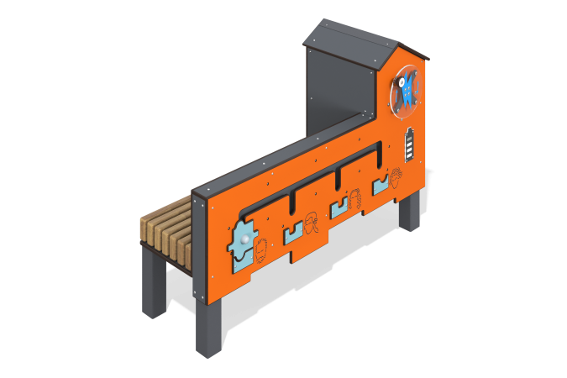

Size, mm: | 567x1507x1014 | Weight, kg: | 391.285
Material characteristics
Educational game module
The module is a “composers” installation with an integrated bench on metal stands. The module consists of a generator set with connected sensors and a speaker located inside an HPL plastic housing. The case is equipped with a charge indicator in the form of a battery, a rotating panel made of monolithic polycarbonate with a handle, the rotation of which charges the generator. The body has slots with a puzzle-shaped slider. When the slider is installed in a certain groove and the generator is charged, it switches between melodies of different composers, whose portraits are depicted under each groove.
On the back side of the module there is a bench with a seat made of planed softwood boards. Materials: HPL plastic, planed board, monolithic polycarbonate, metal, electronic components.

