40.031 |  | Meteor
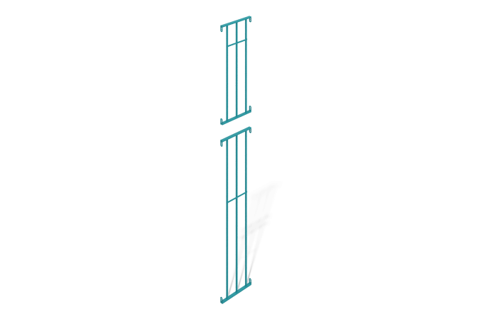

Size, mm: | 40x520x3474 | Weight, kg: | 12.2284
Material characteristics
The span is two independent spans serving to enclose the play area.
Each element of the structure is made of welded together rectangular metal profile pipes with a cross-section of 40 mm x 20 mm and a thickness of 2 mm and a square metal profile of 20 mm x 20 mm and a thickness of 1.5 mm, connecting plates made of sheet steel with a thickness of 3 mm are welded to the ends of the rectangular profile.
Along the entire length of each span element, strips of metal with a thickness of 3 mm are welded at different levels. Welding is carried out according to GOST 14771-76.
The spans are painted with turquoise-blue polymer paint RAL 5018 matte.
Installation: Assembly of the structure at the operating site according to the product passport.

