31.015 |  | Fitness Station Eco Bars
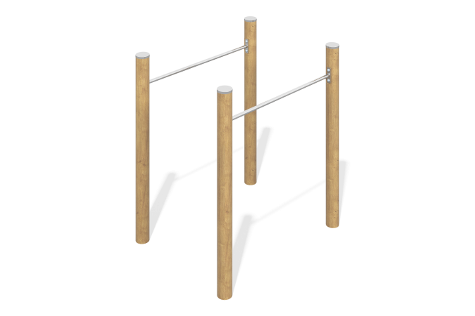

Size, mm: | 730x1550x1600 | Weight, kg: | 185
Material characteristics
Materials: stainless steel, wood (larch).
Contents: Support posts made of larch 130 mm – 4 pcs; crossbars – 2 pcs; lamellas – 8 pcs; embedded elements - 4 pcs., fastening kit - 1 pc.
Design and color palette of equipment according to the sketch.
The complex consists of four glued support pillars with a diameter of 130 mm, made of larch and connected in pairs by crossbars made of a stainless steel pipe with a diameter of 42 mm and a wall thickness of 3 mm. The pillars are sanded and oiled
(two layers).
The upper ends of the pillars are covered with caps made of stainless steel pipe with a diameter of 133 mm and a wall thickness of 4 mm with an elliptical upper cap made of stainless steel with a thickness of 2 mm.

