18.019 |  | Outdoor table Village
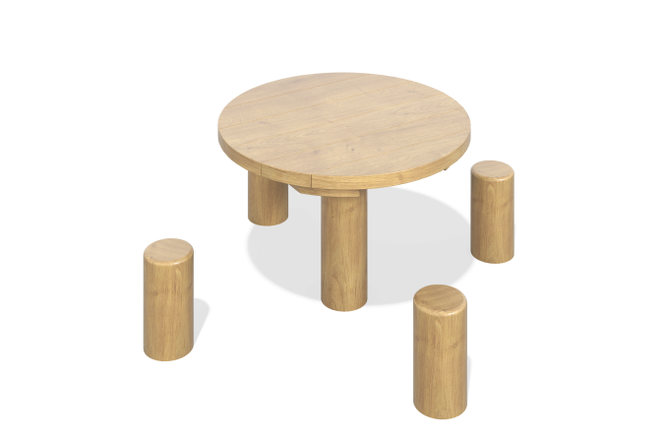

Size, mm: | 1150x1150x590 | Weight, kg: | 0
Material characteristics
Materials: Wood (larch), varnish.
Contents: Glued laminated timber – 5 pcs., table top – 1 pc., fastening kit – 1 pc.
Design and color palette of equipment according to the sketch.
Round table top with two layers.
The top layer is made of larch boards. The bottom one is made of high-strength, moisture-resistant birch plywood 27 mm thick.
The pillars are made of laminated veneer lumber with a diameter of 130 mm.
All surfaces are sanded and oiled (two layers).

