23.017 |  | Play Panel DJ Console
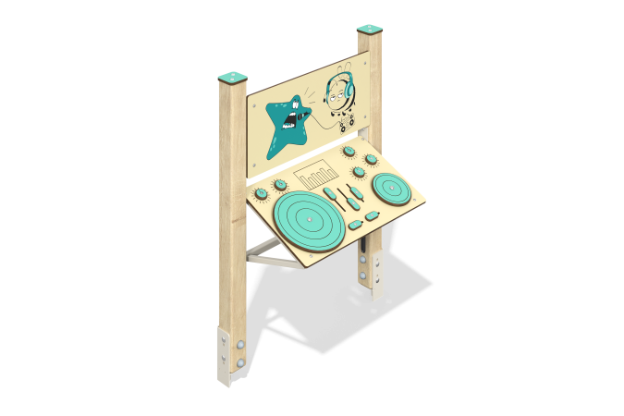

Size, mm: | 402x870x1167 | Weight, kg: | 24.204
Material characteristics
Material: softwood timber, HPL plastic, stainless steel, stainless fasteners.
Contents: embedded parts – 1 set, support stands – 2 pcs., game panels – 2 pcs., fastening kit – 1 pc.
Design and color palette of equipment according to the sketch.
The gaming panel consists of two racks made of timber, between which two panels of HPL plastic are fixed. The support posts are made of laminated coniferous timber with a cross-section of 80x80 mm. The profile is square, the corner radius is R10. The inclined panel is mounted on a frame made of a metal pipe with a diameter of 42.3 mm and a wall thickness of 2.8 mm.
The DJ console gaming element is made of double-sided HPL plastic with UV protection, 10 mm thick. Drawings are applied to the panels using engraving and UV printing. Decorative designs of a star and a bee with musical attributes are applied to the vertical panel. On the inclined panel there are overlays and sliders made of HPL plastic with milling.
Caps made of HPL plastic with UV protection 10 mm thick are installed on the upper part of the support posts.
The gaming panel uses stainless steel fasteners. Protruding parts of threaded connections and open parts of pipes are closed with plastic plugs.
Purpose of the game “DJ Console”: Movable elements imitate changes in the sound settings of the DJ console. The sliders need to be moved up and down. Large and small discs must be moved clockwise.
Element coverage:
- metal - powder zinc primer, powder paint;
- timber - glazing primer, water-dispersion varnish.

