24.007 |  | Sports and Play System Kamchatka
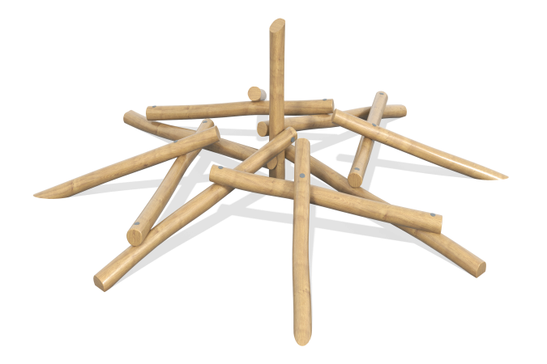

Size, mm: | 3800x3800x1500 | Weight, kg: | 347
Material characteristics
Materials: wood (larch), metal, varnish, powder paint.
Contents: poles – 13 pcs., fastening kit – 1 pc.
Design and color palette of equipment according to the sketch.
The frame consists of 13 round pillars. The pillars are made of laminated larch timber and have a diameter of 130 mm.
All pillars are sanded. The treated surfaces are coated with oil (in two layers).
The pillars are located at different levels and at different angles. The connection of the pillars is made using “studs” 240 mm long made of stainless steel.
The lower ends of the pillars are fixed to the embedded elements.
The mortgage is made of a metal round pipe with a diameter of 33.5 mm and a length of 400 mm.
A support plate is installed in the upper part of the embed, repeating the rounding radius of the log.

