34.107 |  | Park Bench HPL 2m
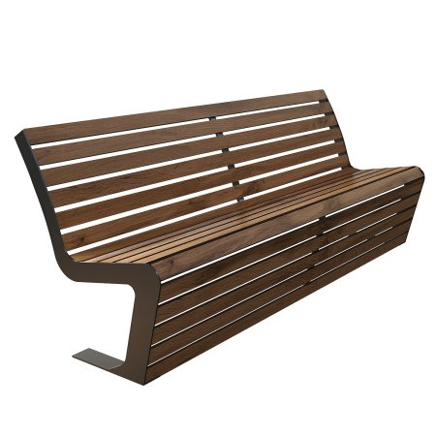

Size, mm: | 1215x2000x1320 | Weight, kg: | 0
Material characteristics
Materials:
metal, plastic
Package includes:
Park sofa – 1 pc.
The 1.5 m long park sofa is equipped with a frame made of galvanized sheet metal 6–8 mm thick with a powder coating, providing protection against corrosion and mechanical damage. The seat and back are made of 12 mm thick HPL plastic with a UF coating, resistant to ultraviolet radiation and atmospheric influences.

