17.053 |  | Swing Frame Claws
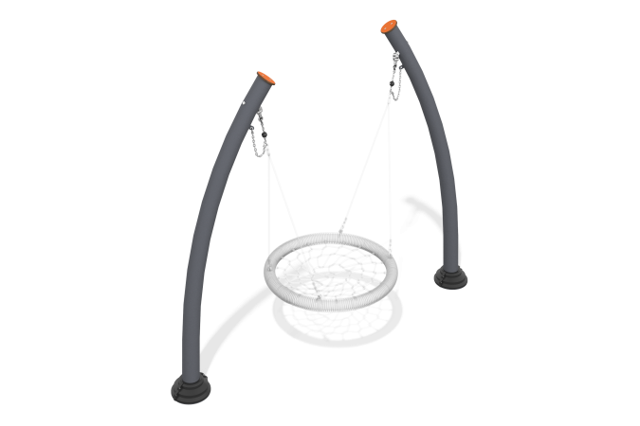

Size, mm: | 1000x2860x2340 | Weight, kg: | 158.834
Material characteristics
The product is a set of a composite frame and a “Nest” swing hanger attached to this frame. All frame pipes have an arched shape, which gives the product an organic appearance.
Materials and components
Powder-painted steel with a layer of zinc-containing primer, stainless steel fasteners. The swing includes a “nest” suspension with a weighted rim. The weaving inside the ring is made of four-strand reinforced rope with a diameter of 16 mm. The swing is equipped with suspensions made of four-strand reinforced rope. The length of the hangers is 1340 mm. The swing is designed for intensive use, can withstand a load of up to 250 kg - suitable for playgrounds in public places (parks, squares, local areas).
Metal parts are coated in two layers: as the first layer, a powder zinc-containing primer is applied, which is a powder mixture based on epoxy resin, zinc and targeted additives, and polymerized in a high-temperature chamber. As a finishing layer, polyester powder paint is applied, which is a homogenized powder mixture of polyester resin, hardeners, pigments, fillers and modifiers selected to ensure weather resistance and light resistance. The finishing layer is polymerized in a high-temperature chamber.
Frame
It consists of two bent pipes on which the “nest” suspension is suspended.
The inclined support posts are made of pipe with a diameter of 108 mm and a wall thickness of 3 mm. The suspension is connected to the support posts through a joint with hinges made of stainless steel 2 mm thick. The suspension is attached to the hinges using a six-strand reinforced rope with a diameter of 16 mm. The polyester included in the braided rope must be resistant to ultraviolet radiation.

