31.010 |  | Fitness Station Triple Pullup
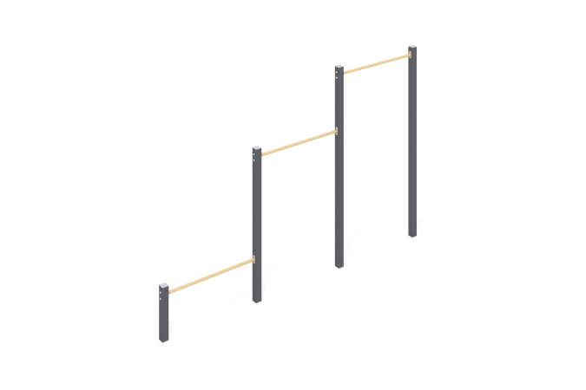

Size, mm: | 80x3870x2500 | Weight, kg: | 82.84
Material characteristics
Materials: metal, powder paint.
The structure consists of:
Profile pipe 80x80x3 (stands)
Pipe DN 25x2.8 mm (crossbars)
The open parts of the profile pipes are closed with plastic plugs;
All available metal parts are painted with polyester powder paint:
The racks are painted;
The bars and crossbars are painted;
The fastening kit is galvanized.
It is concreted to a depth of 500 mm.
Equipment:
Stand – 3 pcs.
Crossbars – 2 pcs.
Fastening kit – 1 pc.
Set of plugs – 1 pc.

