33.008 |  | Information board with door
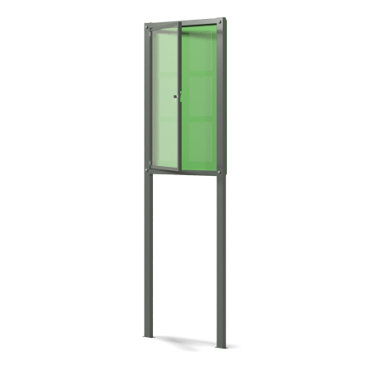

Size, mm: | 90x1000x2000 | Weight, kg: | 39.815
Material characteristics
Materials: plywood, polycarbonate, metal, powder paint.
The structure consists of:
Profile pipe 60mm x 40mm x 3 mm,
Profile pipe 20mm x 20mm x 1.5mm,
15mm thick plywood with six pockets. The door has a weatherproof padlock and is attached to the counter with furniture hinges. The upper parts of the racks are closed with plastic plugs.
All existing metal parts are painted with polyester powder paint.
Equipment:
Frame – 1 piece.
Door with lock – 1 pc.
Shield with six pockets – 1 pc.
Fastening kit – 1 pc.
Set of plugs – 1 pc.

