19.099 |  | Sandpit Virginia
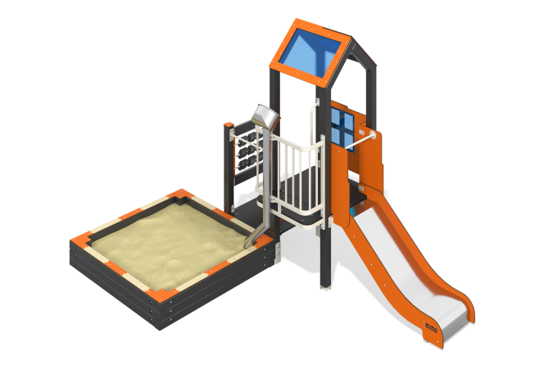

Size, mm: | 2215x3385x2350 | Weight, kg: | 204.353
Material characteristics
Main materials: softwood timber, planed softwood board, laminated plywood with anti-slip coating, HPL plastic, metal, stainless steel, monolithic polycarbonate, stainless fasteners.
Contents: embedded parts – 1 set, support posts – 6 pcs., roofs – 1 set, floors – 1 set, straight slide h=0.7m – 1 pc., balcony with sand pipe – 1 pc., tic-tac-toe game panel – 1 pc., climber’s panel with grooves for feet – 1 pc., sandbox – 1 pc., fastener set - 1 pc.
Design and color palette of equipment according to the sketch.
The sandy courtyard consists of 1 tower. The support posts are made of laminated coniferous timber with a cross-section of 80x80 mm. The profile is square, the corner radius is R10.
The frame of the tic-tac-toe game panel is a planed softwood board with a cross-section of 100x30 mm. Tic-tac-toe is made of laminated coniferous timber with a cross-section of 100x100 mm. The profile is square, the corner radius is R10. The metal plates are made of stainless steel with a thickness of 1.5 mm. The floors and steps are made of laminated plywood 18 mm thick with an anti-slip coating. Fencing and decorative panels, game elements are made of double-sided HPL plastic with UV protection, 10 mm thick. Drawings are applied to panels and game elements using engraving and UV printing. The roofs of the towers are gable, made of a combination of frames made of HPL plastic with monolithic polycarbonate, onto which color coating is applied using UV printing. Decorative inserts on the panels in the form of windows are made of monolithic polycarbonate 5 mm thick with color coating. The handles are made of metal pipe with a diameter of 26.8 mm and a wall thickness of 2.8 mm. The balcony is made of a metal profile pipe 40x20mm with a wall thickness of 2 mm, as well as transverse tubes with a diameter of 21.3 mm and a wall thickness of 2.8 mm. Metal crossbars are made of a round pipe with a diameter of 21.3 mm and a wall thickness of 2.8 mm. The sand pipeline is made of stainless steel: a pipe with a diameter of 76 mm with a wall thickness of 1 mm and a sheet with a thickness of 1.5 mm. The climb to the platform with a slide is presented in the form of a climber's panel with grooves for the legs, made of 10 mm thick HPL plastic.
A straight slide h=0.7 m consists of a slope and sides, in turn made of stainless steel sheet 1.5 mm thick and HPL plastic 10 mm thick. The launch pads for straight slides are equipped with a metal crossbar made of a round pipe with a diameter of 21.3 mm and a wall thickness of 2.8 mm.
The complex uses stainless steel fasteners. Protruding parts of threaded connections and open parts of pipes are closed with plastic plugs.
Element coverage:
- metal - powder zinc primer, powder paint;
- timber - glazing primer, water-dispersion varnish.

