31.005 |  | Fitness Station Gymnastic rope
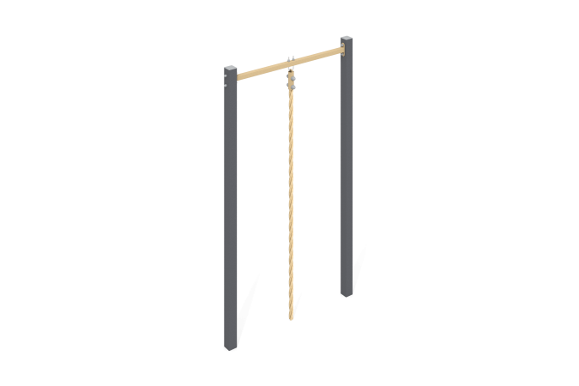

Size, mm: | 80x1330x2500 | Weight, kg: | 50.24
Material characteristics
Materials: metal, powder paint.
The structure consists of:
Profile pipe 80x80x3 (stands)
Pipe DN 25x2.8 mm (crossbar)
Reinforced rope
The open parts of the profile pipes are closed with plastic plugs;
All available metal parts are painted with polyester powder paint:
The racks are painted;
The crossbar is painted;
The fastening kit is galvanized.
It is concreted to a depth of 500 mm.
Equipment:
Stand – 2 pcs.
Crossbars – 1 pc.
Rope – 1 pc.
Fastening kit – 1 pc.
Set of plugs – 1 pc.

