28.133 |  | Climbing blocks Elbrus (HPL)
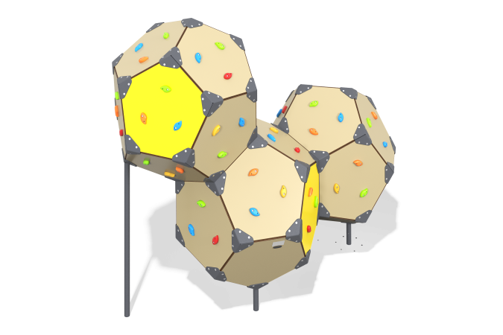

Size, mm: | 1870x3399x2823 | Weight, kg: | 525.2072
Material characteristics
Materials:metal, HPL plastic, stainless fasteners.
Package contents: support posts – 5 pcs., panels – 32 pcs., corners - 45 pcs., a set of fasteners - 1 set.
The equipment consists of three blocks connected to each other and made in the form of a regular dodecahedron. The blocks are made of double-sided HPL plastic with UV protection 10 mm thick.
The metal corners are made of 5 mm sheet steel. The support posts are made of 5 mm thick sheet steel and steel pipe with a diameter of 57 mm and a wall thickness of 3 mm.
The climbing elements are made of composite material.
The equipment uses stainless steel fasteners. The protruding parts of the threaded connections and the exposed parts of the pipes are covered with plastic plugs.
Coating of the elements:
metal - powder zinc grunt, powder paint.

