13.203 |  | Play System Rachmaninov
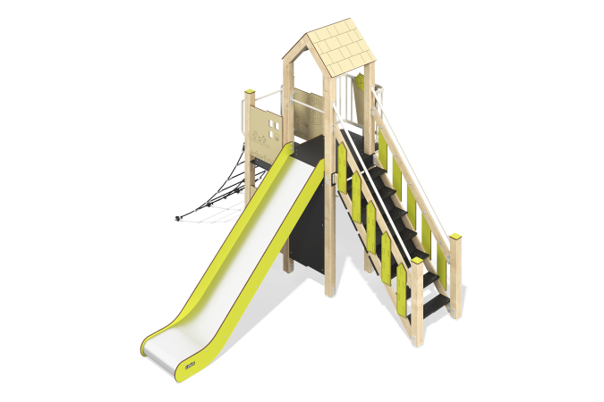

Size, mm: | 3333x4035x3007 | Weight, kg: | 287.26
Material characteristics
Main materials: softwood timber, planed softwood board, laminated plywood with anti-slip coating, HPL plastic, metal, stainless steel, monolithic polycarbonate, reinforced polypropylene rope, stainless fasteners.
Contents: embedded parts – 1 set, support posts – 8 pcs., roofs – 1 set, floors – 1 set, straight slide h=1.5m – 1 pc., fencing and decorative panels – 1 set, drawing board – 1 pc., staircase with decorative panels – 1 pc., balcony with steering wheel – 1 pc., inclined rope mesh - 1 pc., "Flowers" panel - 1 pc., "Race" panel - 1 pc., crossbars - 2 pcs., handles - 2 pcs., fastening kit - 1 pc.
Design and color palette of equipment according to the sketch.
The play complex consists of 1 tower, a slide, a rope ladder and a ladder on support posts. The floors are located at different levels. The support posts are made of laminated softwood timber with a cross-section of 100x100 mm. The profile is square, the corner radius is R10.
The floor frames are planed softwood boards with a section of 100x30 mm, 100x40 mm. The floors and steps are made of laminated plywood 18 mm thick with an anti-slip coating.
The roof of the tower is gable, made of HPL plastic, the design is applied by engraving.
Fencing and decorative panels, game elements are made of double-sided HPL plastic with UV protection, 10 mm thick. Drawings are applied to panels and game elements using engraving and UV printing.
- inclined rope mesh made of six-strand reinforced polypropylene rope d=16 mm.
The handles are made of metal pipe with a diameter of 26.8 mm and a wall thickness of 2.8 mm.
Metal crossbars are made of a round pipe with a diameter of 21.3 mm and a wall thickness of 2.8 mm.
The staircase with decorative panels is made of 24 mm thick plywood, the steps are made of 18 mm thick laminated plywood with an anti-slip coating. The railings are made of pipes with a diameter of 33.5 mm and a wall thickness of 2.8 mm. Decorative panels are made of double-sided HPL plastic with UV protection, 10 mm thick.
The play complex includes 1 straight slide h=1.5 m. The slide consists of a slope and sides, in turn made of stainless steel sheet 1.5 mm thick and HPL plastic 10 mm thick. The launch pad for the straight slide is equipped with a metal crossbar made of a round pipe with a diameter of 21.3 mm and a wall thickness of 2.8 mm.
The complex uses stainless steel fasteners. Protruding parts of threaded connections and open parts of pipes are closed with plastic plugs.
Element coverage:
- metal - powder zinc primer, powder paint;
- timber - glazing primer, water-dispersion varnish.

