25.008 |  | Trampoline Geoplasty square 1350x1350
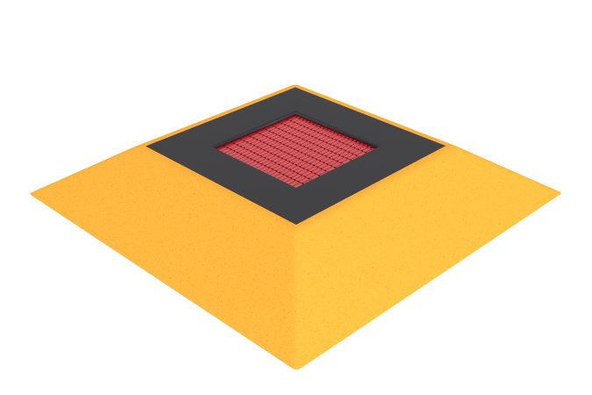

Size, mm: | 2050x2050x310 | Weight, kg: | 280
Material characteristics
Materials: trampoline frame – galvanized steel 3 mm thick; jumping surface - elements made of TPR, steel rope 4 mm thick; trampoline sides – EPDM chips; The geoplastic body is fiberglass, the body coating is TPV chips.
The sports and play element is an artificial hill in the shape of a truncated pyramid with a built-in square trampoline.
The frame of the hill is made of fiberglass. The hill cover is made of TPV crumb and aliphatic polyurethane binder 8 mm thick with a shock-absorbing layer of crumb rubber and polyurethane binder 25 mm thick. The production of the front and shock-absorbing layers is carried out using the cold pressing method. The shock-absorbing layer is reinforced with a profile metal pipe.
The frame of the trampoline is made of galvanized steel sheets 3 mm thick and has additional stiffening ribs inside. The upper part of the housing covers the springs located underneath and is covered with a rubber mat. The remaining part of the building is located inside the hill.
The jumping surface is assembled from assembled elements made of compacted technical thermoplastic elastomer (TEP) with high resistance to abrasion and weathering. The elements of the canvas are connected to each other by steel ropes (cables) 4 mm thick and form a continuous jumping surface without gaps between the individual elements.
The ends of the cables are connected through thimbles to the body using cone-shaped springs hidden under the frame of the trampoline. The springs have a galvanic coating and an elongated ear shape for easy access when servicing the trampoline.
To ensure safety, the edges of the trampoline are covered along the perimeter with rubber plates 300 mm wide and 20 mm thick, made from recycled rubber with the addition of EPDM material. The covering mat covers the body of the trampoline, prevents slipping and softens possible falls.
Contents: Geoplastic with square trampoline 1350x1350 – 1 set.

