MG3526-3 |  | Stump d=400mm
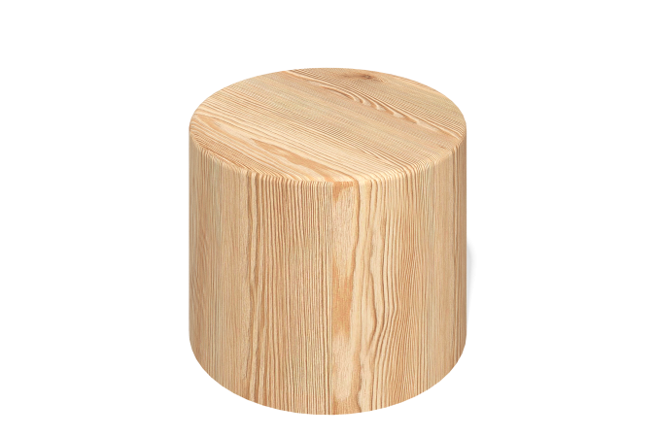

Size, mm: | 400x400x550 | Weight, kg: | 35.91
Material characteristics
Solid larch stump.
Diameter - 400 mm.
Height (total) - 550 mm.
250 mm - depth.
300 mm - from the surface.
Cover the concreted part with sultan.

