26.063 |  | Three level bench
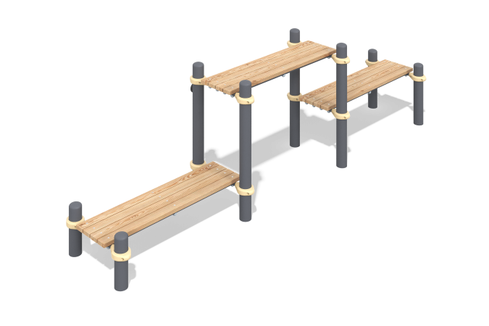

Size, mm: | 808x4200x1225 | Weight, kg: | 29.3142
Material characteristics
Materials: metal, powder paint, wood, varnish.
The recreation bench consists of eight support pillars made of a metal pipe with a diameter of 108 mm with a wall thickness of 3 mm, six crossbars made of a round metal pipe with a diameter of 33.5 mm with a wall thickness of 2.8 mm.
The upper part of the pillars is covered with an elliptical metal plug.
The connection of the crossbars to the support posts is made on collapsible metal clamps with a diameter of 108 mm.
The benches for recreation are made of twelve dry softwood planks with a cross section
35 mm x 90 mm. All the boards are sanded, the upper edges are rounded. The treated surfaces are covered with tinted and colorless varnish.
The equipment uses stainless steel fasteners. The protruding parts of the threaded connections and the exposed parts of the pipes are covered with plastic plugs.
Coating of the elements:
- metal - powder zinc grunt, powder paint
Package contents: support posts – 8 pcs; crossbars – 6 pcs; clamps – 12 pcs., boards - 12 pcs.

