30.082 |  | Basketball unit
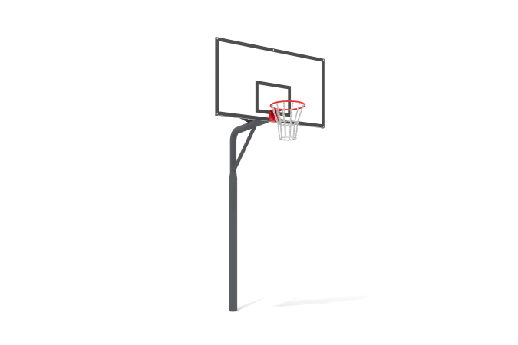

Size, mm: | 1800x2010x3900 | Weight, kg: | 109.859
Material characteristics
Materials: Metal, powder paint, plywood, anti-vandal basketball hoop.
The basketball stand is made of a steel pipe with a diameter of 133 mm with a wall thickness of 4.5 mm, turning into a steel pipe with a diameter of 108 and a wall thickness of 3 mm.
A frame made of a 40x20 mm steel profile pipe with a wall thickness of 2 mm is attached to the stand through a flange.
A basketball backboard made of moisture-resistant plywood is installed on the frame with bolts.
The shield is coated with paint and varnish.
The basketball hoop is secured to the frame with bolts passing through the backboard.
To impart rigidity to the structure, the frame is secured with ties made from a steel profile pipe 40x20 mm with a wall thickness of 2 mm.
All fasteners are galvanized.
All existing metal parts are painted with polyester powder paint.
Contents: Stand - 1 pc. Shield frame - 1 pc. Shield - 1 pc. Anti-vandal basketball hoop - 1 pc. Fastening kit - 1 pc.

