43.038 |  | Bumps
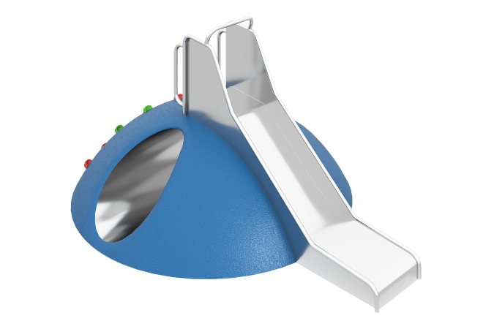

Size, mm: | 2350x2350x750 | Weight, kg: | 250
Material characteristics
Materials: metal, plastic, rubber
Package includes: mound with tunnel – 1 pc., straight slide – 1 pc.,
The mound with tunnel and slide is a single piece, ready for installation by gluing or anchoring. The structure is made on a durable fiberglass frame, reinforced with metal pipes 25×25×2 mm, without the use of bulk fillers. The outer coating is EPDM crumb on an aliphatic binder 8 mm thick with a shock-absorbing layer of rubber crumb (20 mm), made by cold pressing. The built-in tunnel is made of stainless steel AISI 304 (1.5 mm, 2B), shifted inward by 25 mm for safe mating with the coating. The slide is made of AISI 304 stainless steel (2 mm thick) and includes a starting section (length 350 mm, angle 5°, height 770 mm), a sliding section (length 850 mm, angle 40°) and an ending section (length 800 mm, angle 5°), with a smooth transition with a radius of 600 mm. The hooks are secured using stainless steel fasteners.

