43.037 |  | Hemisphere with a tunnel
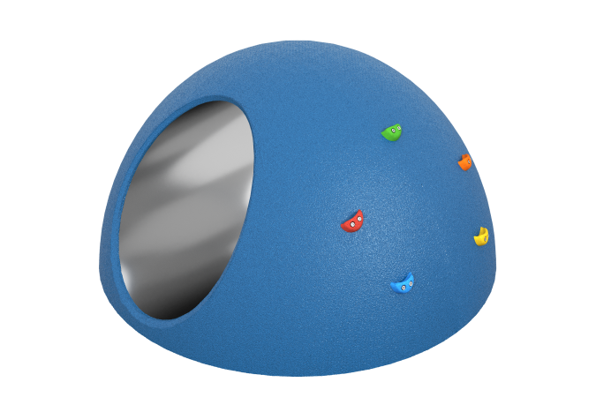

Size, mm: | 1500x1500x750 | Weight, kg: | 150
Material characteristics
Materials: metal, plastic, rubber
Package includes: hemisphere – 1 pc.
The hemisphere with a tunnel is a single element, ready for installation, with the possibility of fastening to the base by gluing or anchoring. The product is made on a fiberglass frame, reinforced with a 25×25×2 mm metal pipe, without the use of bulk fillers and unacceptable materials. The outer coating is made of EPDM crumb on an aliphatic polyurethane binder (8 mm) with a shock-absorbing layer of rubber crumb on an aromatic binder (20 mm), using open molding and cold pressing. The built-in tunnel with a diameter of 600 mm is made of AISI 304 stainless steel with a thickness of 1.5 mm with a 2B surface, shifted inside the structure by 25 mm for safe mating with the coating; Welding and beading in the abutment area are not permitted.

