43.036 |  | Hummock with a tunnel
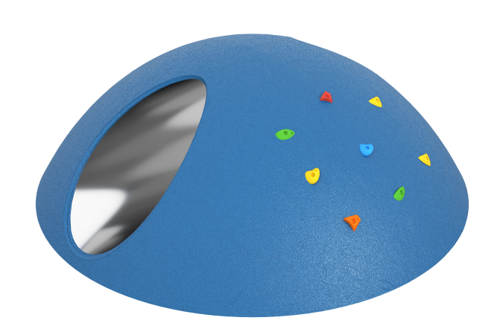

Size, mm: | 2350x2350x770 | Weight, kg: | 250
Material characteristics
Materials: metal, plastic, rubber
Complete set: hummock with tunnel – 1 pc.
The product is supplied as a single element, ready for installation, with the possibility of fastening to the base by gluing or anchoring. The base is made on a fiberglass frame, reinforced with a 25×25×2 mm metal pipe, without the use of bulk fillers and unacceptable materials. The coating is EPDM crumb with a face layer on an aliphatic polyurethane binder 8 mm thick and a shock-absorbing layer of rubber crumb with an aromatic binder 20 mm thick. The built-in tunnel with a diameter of 600 mm is made of AISI 304 stainless steel 1.5 mm thick with a 2B surface; the pipe is offset inward by 25 mm for a safe connection with the coating, while welding of the profile pipe and beading at the junction are not allowed.

