31.071 |  | Sports station Merbold
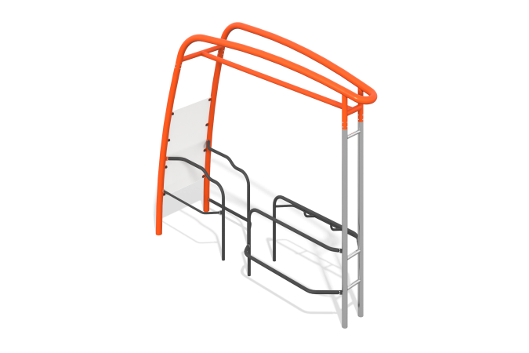

Size, mm: | 1087x3910x3374 | Weight, kg: | 338
Material characteristics
Materials: metal.
Complete set: supports - 4 pcs., fastener kit - 1 pc.
The frame of the sports complex is made of metal and stainless steel pipes 76 mm. and 102 mm, with a polymer protective coating of orange and gray colors, the information plate is made of plastic at least 8 mm thick, with printed application of types of exercises, with a protective finishing coating of two-component polyurethane varnish.
Protruding parts of threaded connections and open parts of pipes are covered with plastic plugs
Coating of elements: metal - powder zinc primer, powder paint.

