43.033 |  | Hummock
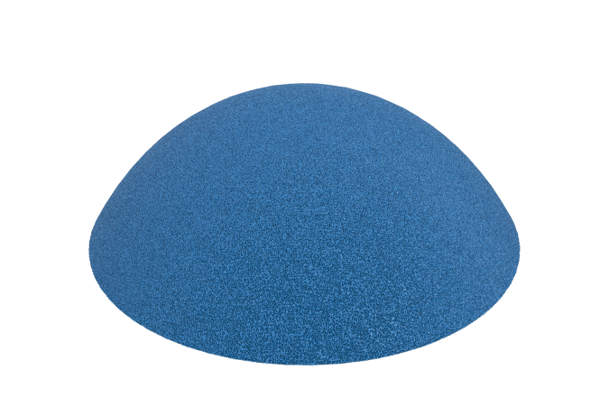

Size, mm: | 400x400x120 | Weight, kg: | 6
Material characteristics
Materials: metal, plastic, rubber
Includes: hummock – 1 pc.
The product is a one-piece element, ready for installation, with the possibility of fastening to the base by gluing or using anchors. The coating is made of EPDM crumb with an aliphatic polyurethane binder 8 mm thick and a shock-absorbing layer of rubber crumb with aromatic polyurethane 40 mm thick. Both surfaces are made by cold pressing under pressure. The shock-absorbing layer is reinforced with a metal profile pipe that acts as a base, without the use of bulk fillers and frames made of sand, concrete or plywood.

