34.089 |  | Information Board
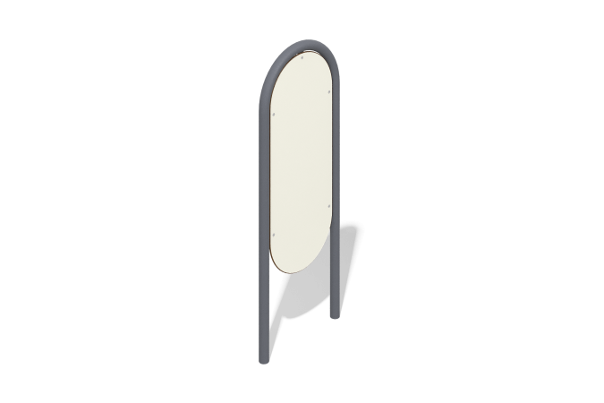

Size, mm: | 190x745x1710 | Weight, kg: | 25.6
Material characteristics
Materials: metal, HPL plastic.
Contents: stand – 1 pc., shield – 1 pc., fastening kit – 1 pc.
Design and color palette of equipment according to the sketch.
The product consists of a shield mounted on a stand. The shield is made of HPL plastic 10 mm thick, the arc stand is made of a metal round pipe with a diameter of 57 mm and a wall thickness of 3 mm.
All open parts of pipes and bolted connections are closed with plastic plugs of the appropriate size.
Element coverage:
- metal - powder zinc primer, powder paint.

