17.011 |  | Steel Swing Frame For 3 Seats
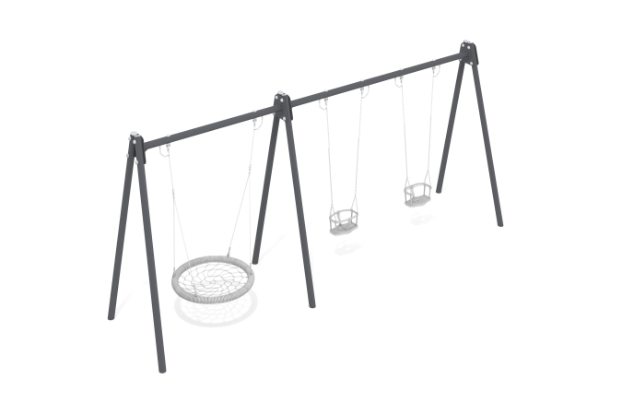

Size, mm: | 1460x6585x2640 | Weight, kg: | 205.98
Material characteristics
The frame is a structure consisting of 6 supports made of metal round pipes and 2 crossbars fixed between them. Round pipes with a diameter of 89mm and a wall thickness of 3mm.
Metal painting is done with polymer paint. All open parts of pipes and bolted connections are closed with plastic plugs.
Frame elements:
Support post – 6 pcs.
Crossbar – 2 pcs.
Hanging fasteners – 6 sets.
Fastening kit – 1 pc.
Plug 89 mm - 6 pcs.

