17.215 |  | Three-section metal swing
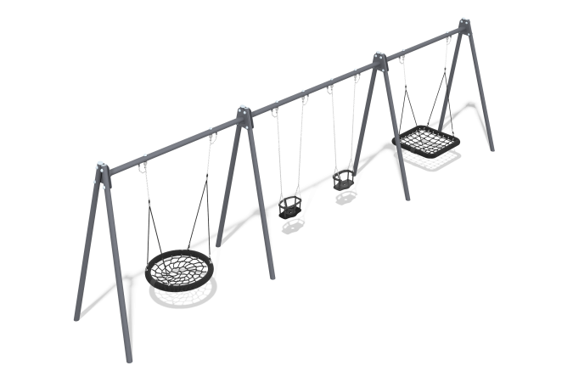

Size, mm: | 1460x9470x2640 | Weight, kg: | 0
Material characteristics
The frame is a structure consisting of 8 supports made of metal round pipes and 3 crossbars fixed between them. Round pipes with a diameter of 89mm and a wall thickness of 3mm.
Fastening elements: M12x130 bolts, self-locking nuts, washers, fasteners for suspension. Metal painting is done with polymer paint
. All open parts of pipes and bolted connections are closed with plastic plugs. Installation is carried out by deepening the lower part of the rack to a depth of 0.6 m, followed by concreting.
Frame elements:
Support post – 8 pcs.
Crossbar – 3 pcs.
Hanging fasteners – 8 sets.
Fastening kit – 1 pc.
Plug 89 mm - 8 pcs.

