13.109 |  | Play System Climbing
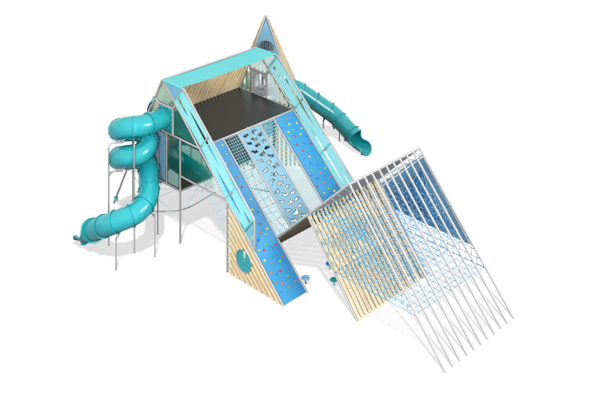

Size, mm: | 14600x18800x6800 | Weight, kg: | 0
Material characteristics
Materials: metal, HDPE plastic, HPL panels, laminated waterproof plywood, polypropylene six-strand reinforced rope, polycarbonate, stainless steel fasteners, softwood beams.
Thematic complex "Rock Climbing" will allow children to feel like real climbers: climb a mountain, go down a steep slope. The complex imitates a mountain range and consists of three peaks equipped with different sports and game elements. The first peak is equipped with rope tiers, swings and a track for running with obstacles.
The second peak has three tiers. On the first tier there are elements for climbing from a rope, a game element "Lift yourself". The ascent to the second tier is carried out along a rope net. The second tier is a platform from which you can go to the third peak along a suspension bridge made of rope, or along a plastic pipe. On the second tier there is a game labyrinth "Climbing to the top".
The third tier is also a platform, the ascent to which is carried out along a rock-climbing wall with three types of climbing walls. The platform is equipped with a descent along a spiral plastic slide and a transition to the third peak along a pipe made of metal mesh.
The third peak is equipped with a rope climb and a descent along a pipe slide.
When designing, it is necessary to take into account that the dimensions of the complex can change when modifying the model both in a smaller and larger direction. We recommend adding an additional space from half a meter to one meter in each direction to the calculated landing zone.
The manufacturer can change the described parameters as part of improving the design and consumer properties of the product.
Metal parts are covered with two layers: the first layer is a powder zinc-containing primer, which is a powder mixture based on epoxy resin, zinc and target additives, polymerized in a high-temperature chamber. The finishing coat is polyester powder paint, which is a homogenized powder mixture of polyester resin, hardeners, pigments, fillers and modifiers selected to ensure weather resistance and light resistance. The finishing coat is polymerized in a high-temperature chamber. The following components are used in the design: plastic plugs for the ends of pipes, plastic composite caps for fasteners, stainless steel fasteners, special fasteners for swing hangers, stainless steel chain.
Frame
The frame of the complex consists of steel pipes. Boards are used as tightening elements. Additional frame elements are made of DN25 pipes with a diameter of 33.5 mm and a wall thickness of 2.8 mm. Welded strappings secured with bolted connections are used to connect the pipes, as well as clamps with adapters for fastening frame elements consisting of DN25 pipes. All metal frame elements are painted with powder paint with a layer of zinc-containing primer.
All metal parts undergo cleaning, degreasing and shot blasting before coating.
Fillings and fencing
Decorative, structural and play panels are made of durable, moisture-resistant and UV-resistant HDPE plastic 15 mm thick and (or) HPL 10 mm thick. Cast polycarbonate (LPC) plates 10 mm thick. Impact-resistant sheet material, translucent, has no internal voids.
Rope nets are made of UV-resistant polypropylene six-strand reinforced rope with a diameter of 16 mm. Rope connections are made of durable plastic and (or) specialized stainless or aluminum fasteners. The floors of the platforms are made of high-strength moisture-resistant laminated plywood, covered with phenolic or melamine film 120-220 g / m2, with a signature pattern "hexagonal structure".
All edges of parts made of sheet plastics HDPE, HPL are processed and smoothed using special edge knives or milling.
Slides
The complex includes two plastic tunnel slides. One is a spiral, the second is straight with a turn.
The lower part of the plastic tunnel slide has a straight, open "braking" section.
Sports products
The complex includes a rope ladder, a rope wave wall, "bumps" for developing balance, a square-shaped "nest" swing. A "nest" suspension with a weighted rim. The weaving inside the ring is made of a four-strand reinforced rope with a diameter of 16 mm. The diameter of the rim after braiding with rope is 900 mm. The swing is equipped with suspensions made of four-strand reinforced rope. The length of the suspensions is 1340 mm.
Nets
The complex includes manholes and “nets” made of reinforced polypropylene rope with a diameter of 16 mm, consisting of six strands, each strand is reinforced with eight metal wires.
Interactive elements
The complex includes special developments - interactive elements, exhibits, educational stands and modules for games.
Who is faster to the peak?
The module is a labyrinth in which players are invited to move the figures of skiers.
Lift yourself
The element is a structure consisting of a frame made of HDPE on which a plastic seat is installed. The frame can move up and down along metal guides, due to the tug of war over the blocks.
The exhibit clearly shows the “Golden Rule of Mechanics”:
where there is a gain in force, there is a loss in distance. The effect is created by round blocks through which your rope is passed. They act as a lever. The blocks reduce the effort required to lift yourself, so it has become 6 times easier for you to lift yourself. This is a gain in strength. On the other hand, you have unwound 6 times more rope than the height to which you have climbed. This is a loss in distance. Theoretically, the rope can be passed through 100 blocks. You will be able to lift a huge weight, but you will have to unwind hundreds of meters of rope.
The design includes a frame fixed on two guides and an upper block of rollers. The frame and the upper block of rollers are connected by a rope with a diameter of 20 mm.
Dimensions of the exhibit: 1040x2300x200 mm.
Materials used: metal frame and guides.
The facades of the exhibit are made of 15 mm HDPE plastic and (or) 10 mm HPL panels.

