14.006 |  | Carousel Nest
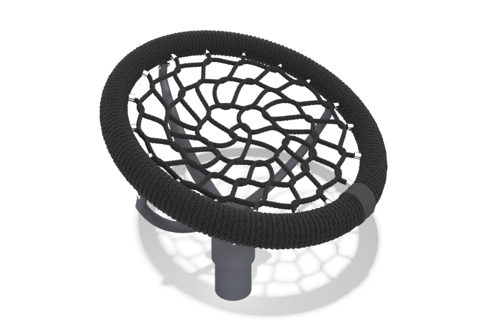

Size, mm: | 1042x1042x809 | Weight, kg: | 35
Material characteristics
Materials: metal, rope.
Complete set: rocking frame - 1 pc., rope net - 1 pc., fastener kit - 1 pc.
The design consists of: A concrete stand with a rotation unit, height 1061 mm, external pipe diameter 133 mm. In the upper part of the stand, a round flange with a diameter of 260 mm with four holes is installed for attaching a crosspiece to it and transmitting rotational motion. Crosspiece mount. It has a geometric shape of a trident, made of bent pipes with a diameter of 32 mm, welded together and to a metal plate with a thickness of 5 mm and a diameter of 260 mm. Ring nest with an external diameter of 1040 mm, thickness 100 mm. The rim of the seat is a metal pipe with an external diameter of 25 mm, painted with protective paint against rust, wrapped on top with a 3-strand rope made of complex polypropylene, the rope diameter is 19 mm. It is installed over the crosspiece and fixed. The braided mesh is made of reinforced, four-strand rope, the rope diameter is 16 mm. At the ends of the braided mesh, fasteners are crimped into steel bushings, which allows the mesh to be connected to the seat rim. All metal elements that are not rotation units are painted with powder paint on the ground.
The protruding parts of the threaded connections and open parts of the pipes are covered with plastic plugs
Coating of elements: metal - powder zinc primer, powder paint.

