ML4525.1 |  | Workout MG-25.1
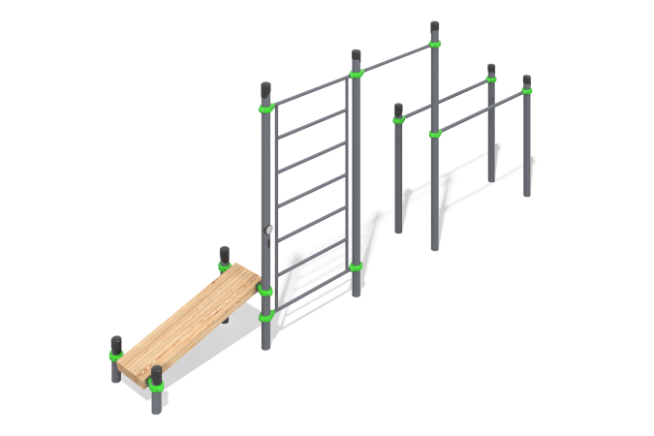

Size, mm: | 740x5800x2630 | Weight, kg: | 234.3875
Material characteristics
Materials:
Softwood timber (pine), metal.
Components:
Support posts - 9 pcs,
bench - 1 pc,
climbing ladder - 1 pc,
bars - 4 pcs,
fastener kit - 1 set.
Specifications:
Support Posts: Made from round steel tubing with an outer diameter of 89 mm and a wall thickness of 3 mm.
Bars: Constructed from round steel tubing with an outer diameter of 40 mm and a wall thickness of 3 mm.
Climbing Ladder: Fabricated from round tubing with an outer diameter of 33.5 mm and a wall thickness of 2.8 mm.
Connection Hardware: Metal components are secured using die-cast aluminum clamps. These clamps are designed for connecting perpendicular tubes, specifically for fixing a horizontal bar to a vertical 89 mm diameter post.
Press Bench: The equipment includes a press bench. The bench is made from laminated pine timber (profile B) with dimensions of 100x100 mm.
Fasteners: Stainless steel fasteners are used throughout the assembly.
Safety Finishes: Protruding threads and open tube ends are covered with protective plastic caps.
Surface Coating:
Metal: Zinc-rich primer with a powder coating finish.
Timber: Tinted primer followed by a water-based dispersion varnish.

