26.017 |  | Workout System Hand-walker
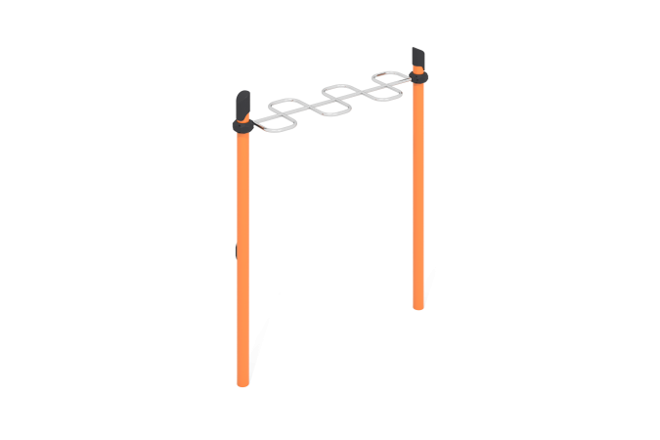

Size, mm: | 550x1810x2600 | Weight, kg: | 77
Material characteristics
Materials: metal, powder paint, stainless steel, plastic.
Contents: support posts – 2 pcs; snake handlebar – 1 piece; clamps – 1 set; fastening kit – 1 pc.
The complex consists of 2 support pillars and a snake walker.
The support pillars are made of metal pipe with a diameter of 108 mm and a wall thickness of 3.5 mm. The upper part of the pillars is closed with a plastic plug with a truncated cap.
The snake handle is made of a stainless metal round pipe with a diameter of 32 mm and a wall thickness of 2 mm.
The connection of the gymnastic element is made using collapsible clamps. There are rubber sealing inserts for reliable fixation - the clamp fits tightly to the pipe and does not slip during operation.
The clamp consists of 2 elements that are fixed together with bolts and nuts. The maximum load on the crossbar is 500 kg.
All existing metal parts, except stainless steel, are pre-cleaned, degreased and painted with polyester powder paint. All threaded fasteners are galvanized.

