26.040 |  | Workout System LGVO-413
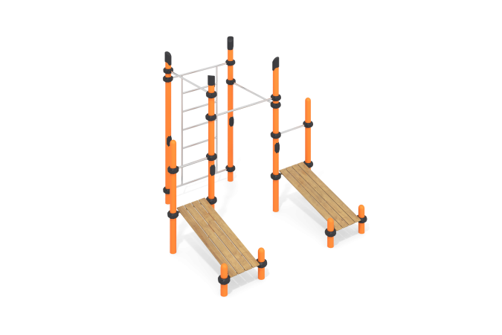

Size, mm: | 2700x3030x2600 | Weight, kg: | 305
Material characteristics
Materials: metal, powder paint, stainless steel, plastic, acrylic paint, varnish, wood.
The complex consists of 10 support pillars made of a metal pipe with a diameter of 108 mm with a wall thickness of 3.5 mm, crossbars and a Swedish vertical ladder made of a round metal pipe with a diameter of 32 mm with a wall thickness of 2 mm, made of stainless steel. The upper part of the pillars is closed with a plastic plug with a truncated cap.
The crossbars and gymnastic elements are connected to dismountable plastic clamps designed to connect two perpendicularly located pipes Ø108 mm and Ø32 mm. Made from glass-filled polyamide (PA6-GF30). The material is characterized by excellent performance characteristics: increased strength and durability, resistance to impact loads, the influence of high and low temperatures (from – 40 to +60 ° C) and UV radiation. There are rubber sealing inserts for reliable fixation - the clamp fits tightly to the pipe and does not slip during operation. The clamp consists of 2 elements that are fixed together with bolts and nuts. The maximum load on the crossbar is 500 kg.
The complex includes: abdominal benches – 2 pcs., a Swedish vertical ladder and three horizontal bars.
The surface of the press bench is made of dry coniferous boards with a cross-section of 36 mm x 120 mm. All boards are sanded, the top edges are rounded. The treated surfaces are covered with tinted and colorless varnish.
All existing metal parts are cleaned and painted with polyester powder paint. All threaded fasteners are galvanized.
Contents: support posts – 10 pcs; crossbars – 5 pcs; vertical ladder – 1 piece; press bench – 2 sets, clamps – 22 pcs.; fastening kit – 1 pc.

