26.041 |  | Workout System LGVO-427
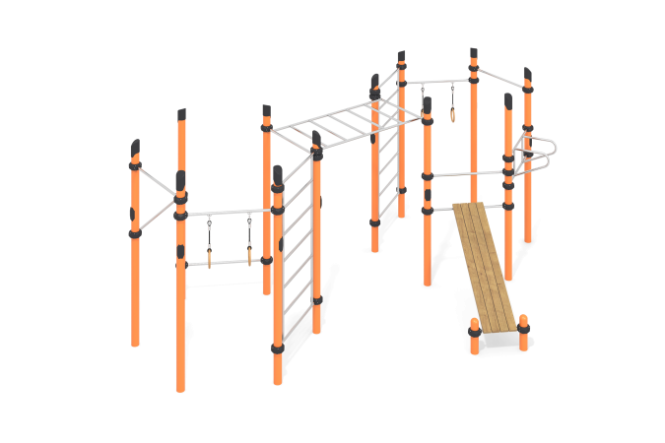

Size, mm: | 3700x6200x2600 | Weight, kg: | 538
Material characteristics
Materials: metal, stainless steel, powder paint, wood, moisture-resistant birch plywood, varnish.
The complex consists of 14 support pillars made of a metal pipe with a diameter of 108 mm and a wall thickness of 3.5 mm, the upper part of which is closed with a plastic decorative plug for pipes having a truncated cap with rounded edges.
The complex includes two Swedish ladders, a monkey bars, an inclined board for the press, an emphasis for the press, two bars with gymnastic rings, and four bars.
All crossbars, gymnastic elements and the frame of the press bench are made of a round pipe with a diameter of 32 mm with a wall thickness of 2 mm, made of stainless steel.
The crossbars and gymnastic elements are connected to dismountable plastic clamps designed to connect two perpendicularly located pipes with a diameter of 108 mm and 32 mm. The clamp consists of 2 elements that are fixed together with bolts and nuts. The elements are made of glass-filled polyamide. There are rubber sealing inserts for reliable fixation - the clamp fits tightly to the pipe and does not slip during operation.
The gymnastic rings are made of high-strength, moisture-resistant birch plywood 27 mm thick and coated in two layers of tinted and colorless varnish.
The bench covering is made of dry milled boards with a cross-section of 36x120 mm of coniferous wood. The upper edges have a rounding radius (from 3 to 10 mm). Treated surfaces are covered with tinted and colorless varnish.
All existing metal parts are painted with polyester powder paint.
All threaded fasteners are galvanized.
Complete set: support posts – 14 pcs; crossbars – 7 pcs; gymnastic rings – 2 sets; handlebar – 1 pc.; Swedish ladder – 2 pcs.; rounded beams – 1 set; crossbar with rings – 2 sets; board for the press – 1 set; clamps – 34 pcs.

