26.042 |  | Workout System LGVO-429
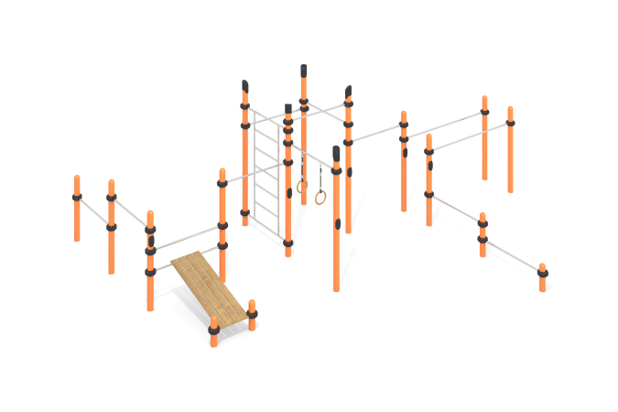

Size, mm: | 5600x6150x2600 | Weight, kg: | 431
Material characteristics
Materials: metal, stainless steel, powder paint, wood, varnish
The complex consists of 17 support pillars made of a metal pipe with a diameter of 108 mm and a wall thickness of 3.5 mm, the upper part of which is closed with a plastic decorative plug for pipes, which has a truncated cap with rounded edges.
The crossbars and gymnastic elements are connected to dismountable plastic clamps designed to connect two perpendicularly located pipes Ø108 mm and 32 mm. The clamp consists of 2 elements that are fixed together with bolts and nuts. The elements are made of glass-filled polyamide (PA6-GF30). The material is characterized by increased strength and durability, resistance to shock loads, the influence of high and low temperatures (from – 40 to + 60 ° C) and UV radiation. There are rubber sealing inserts for reliable fixation - the clamp fits tightly to the pipe and does not slip during operation.
The maximum load on the crossbar is 500 kg. The crossbars, the Swedish ladder, and the frame of the press bench are made of a round pipe with a diameter of 32 mm with a wall thickness of 2 mm, made of AISI 304 stainless steel.
The frame of the press bench has “ears” for fixing the bench flooring. The bench covering is made of dry milled boards with a cross-section of 36x120 mm of coniferous wood. The upper edges have a rounding radius (from 3 to 10 mm). The treated surfaces are covered with tinted and colorless varnish.
The gymnastic rings are made of high-strength, moisture-resistant birch plywood 27 mm thick and coated in two layers of tinted and colorless varnish.
All existing metal parts are painted with polyester powder paint.
All threaded fasteners are galvanized.
Contents: support posts – 17 pcs; crossbars – 11 pcs; bars – 1 set; crossbar with rings – 1 set; Swedish ladder – 1 pc.; clamps – 17 sets.

