26.037 |  | Workout System LGVO-429.1
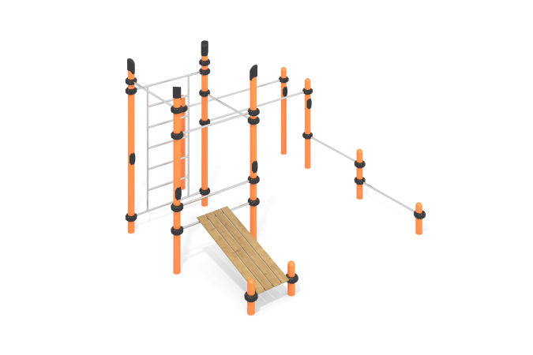

Size, mm: | 2570x3400x2600 | Weight, kg: | 301
Material characteristics
Materials: metal, powder paint, stainless steel, plastic, wood, varnish.
The complex consists of 11 support pillars made of a metal round pipe with a diameter of 108 mm and a wall thickness of 3.5 mm, the upper part of which is closed with a plastic decorative plug for pipes having a truncated cap with rounded edges.
The crossbars and gymnastic elements are made of a round pipe with a diameter of 32 mm with a wall thickness of 2 mm, made of stainless steel.
The crossbars and gymnastic elements are connected to dismountable plastic clamps designed to connect two perpendicularly located pipes Ø108 mm and Ø32 mm. Made from glass-filled polyamide (PA6-GF30). The material is characterized by increased strength and durability, resistance to shock loads, the influence of high and low temperatures (-40 to +60 ° C) and UV radiation. There are rubber sealing inserts for reliable fixation - the clamp fits tightly to the pipe and does not slip during operation.
The clamp consists of 2 elements that are fixed together with bolts and nuts. The maximum load on the crossbar is 500 kg.
The frame of the press bench and all the crossbars are made of a metal round pipe with a diameter of 32 mm with a wall thickness of 2 mm, made of AISI 304 stainless steel. The press bench is made of dry softwood boards with a section of 36 mm x 120 mm. All boards are sanded, edges are rounded. The treated surfaces are covered with tinted and colorless varnish.
All existing metal parts are painted with polyester powder paint.
All threaded fasteners are galvanized.
Contents: support posts – 11 pcs; crossbars – 6 pcs; bars – 1 set; Swedish ladder – 1 piece; press bench – 1 set, clamps – 24 pcs., fastening kit – 1 pc.

