26.044 |  | Workout System Triple Cascade
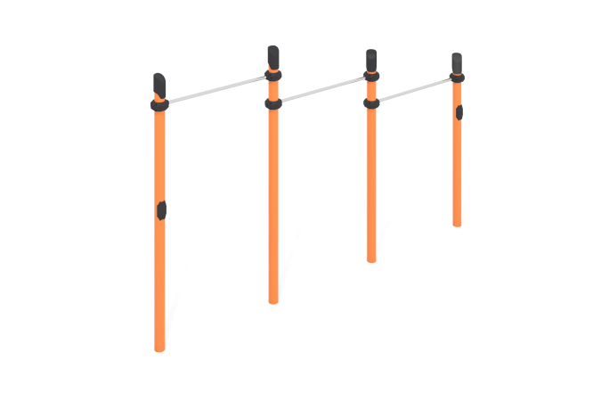

Size, mm: | 150x3775x2600 | Weight, kg: | 133
Material characteristics
Materials: metal, powder paint, stainless steel, plastic.
The complex consists of four support pillars installed in one line and made of a metal pipe with a diameter of 108 mm with a wall thickness of 3.5 mm and three crossbars located at different levels, made of a round pipe with a diameter of 32 mm with a wall thickness of 2 mm, made of stainless steel.
The upper part of the pillars is closed with a plastic plug with a truncated cap.
The crossbars are connected using dismountable plastic clamps designed to connect two perpendicularly located pipes Ø108 mm and Ø32 mm. The clamp consists of 2 elements that are fixed together with bolts and nuts. Made from glass-filled polyamide (PA6-GF30). The material is characterized by excellent performance characteristics: increased strength and durability, resistance to impact loads, the influence of high and low temperatures (from – 40 to +60 ° C) and UV radiation. There are rubber sealing inserts for reliable fixation - the clamp fits tightly to the pipe and does not slip during operation.
The maximum load on the crossbar is 500 kg.
All existing metal parts are painted with polyester powder paint.
All threaded fasteners are galvanized.
Contents: support posts – 4 pcs., crossbars – 3 pcs., clamps – 6 pcs., fastening kit – 1 pc.

