26.010 |  | Workout System Two Pullups and benches
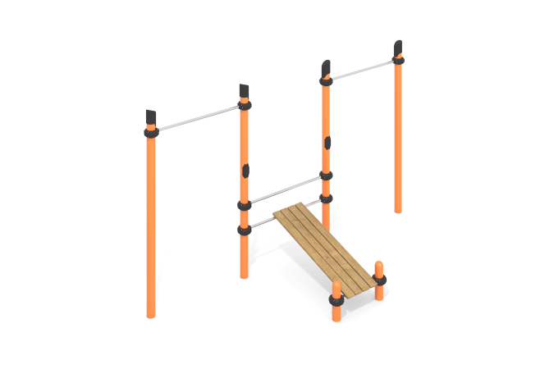

Size, mm: | 1600x3300x2600 | Weight, kg: | 179
Material characteristics
Materials: metal, stainless steel, plastic, powder paint, varnish, wood.
The complex consists of 6 support pillars made of a metal round pipe with a diameter of 108 mm and a wall thickness of 3.5 mm. The upper part of the pillars is closed with a plastic plug with a truncated cap.
The crossbars are made of a metal round pipe with a diameter of 32 mm with a wall thickness of 2 mm, made of stainless steel.
The crossbars and gymnastic elements are connected to dismountable multifaceted plastic clamps designed to connect two perpendicularly located pipes Ø108 mm and Ø32 mm. The clamp consists of 2 elements that are fixed together with bolts and nuts. Made from glass-filled polyamide (PA6-GF30). The material is characterized by excellent performance characteristics: increased strength and durability, resistance to impact loads, the influence of high and low temperatures (from – 40 to +60 ° C) and UV radiation. There are rubber sealing inserts for reliable fixation - the clamp fits tightly to the pipe and does not slip during operation.
The maximum load on the crossbar is 500 kg.
The frame of the press bench is made of a metal round pipe with a diameter of 32 mm, made of stainless steel, and has “ears” with holes for fasteners.
The bench covering is made of dry milled boards with a cross-section of 32mm x 110mm of coniferous wood. The edges have a rounding radius (from 3mm to 10mm).
The treated surfaces are covered with tinted and colorless varnish.
All existing metal parts are painted with polyester powder paint.
All threaded fasteners are galvanized.
Contents: support posts – 6 pcs; crossbars – 5 pcs; clamps – 10 pcs; press bench – 1 set.

