13.183 |  | Play System Thorium
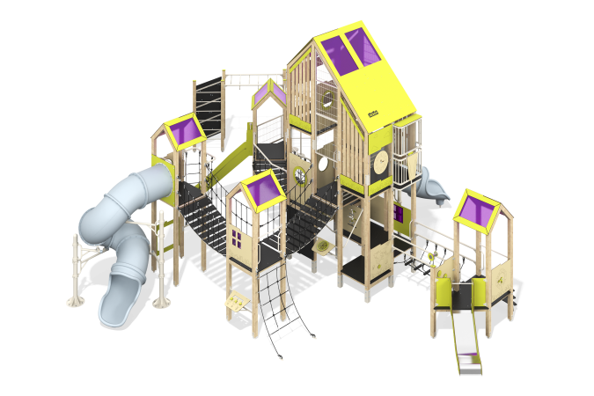

Size, mm: | 10419x12897x6023 | Weight, kg: | 3119.8705
Material characteristics
Main materials: softwood timber, planed softwood board, laminated plywood with anti-slip coating, HPL plastic, HDPE plastic, metal, stainless steel, monolithic polycarbonate, reinforced polypropylene rope, stainless fasteners.
Contents: Embedded parts - 36 pcs. ; Support posts - 48 pcs. ; roofs - 5 pcs., enclosing panels and play panels - 23 pcs., straight slides - 2 pcs., spiral tunnel slides - 4 pcs., spiral slide supports - 2 pcs., stepladder - 1 pc., rope mesh - 2 pcs., rope ladder - 1 pc., monkey bars - 1 pc., gymnastic rings - 1 pc., climber's board - 1 pc., metal fences - 2 pcs., wooden vertical fences - 3 pcs., metal mesh fences - 3 pcs., balcony - 1 pc., spiral staircase - 1 pc., vertical rope mesh - 1 pc., climber panel with hooks - 1 pc., suspension bridges - 2 pcs., arc bridge - 1 pc., straight bridge - 1 pc., ladder - stepladder - 1 pc., set of fasteners - 1 pc.
Design and color palette of equipment according to the sketch.
The gaming complex consists of 5 multi-level towers. The support posts are made of laminated softwood timber with a cross-section of 100x100 mm. The profile is square, the corner radius is R10.
The transition between the towers is presented in the form of a rope bridge made of six-strand reinforced polypropylene rope d = 16 mm with multi-step steps made of laminated plywood 18 mm thick with an anti-slip coating. The rope bridge railing is made of a metal pipe with a diameter of 42.3 mm and a wall thickness of 2.8 mm.
The lifts to the complex are presented in the form of a vertical rope mesh made of six-strand reinforced polypropylene rope d=16 mm with a metal frame made of a metal profile pipe with a section of 60x40 mm and a wall thickness of 2 mm; climber panels with hooks and steps made of 18 mm thick laminated plywood with anti-slip coating; vertical rope mesh made of six-strand reinforced polypropylene rope d=16 mm on a frame made of metal pipe with a diameter of 42.3 mm and a wall thickness of 2.8 mm; inclined rope mesh made of six-strand reinforced polypropylene rope d=16mm; the spiral staircase is made of a pipe with a diameter of 42 mm with a wall thickness of 2.8 mm, the landings are made of a pipe with a diameter of 33.5 mm with a wall thickness of 2.8 mm and a sheet of corrugated metal with a thickness of 4 mm. The floor frames are planed softwood boards with a section of 100x30 mm, 100x40 mm. The floors and steps are made of laminated plywood 18 mm thick with an anti-slip coating. The roofs of the towers are gable, made of a combination of frames made of HPL plastic with monolithic polycarbonate, onto which color coating is applied using UV printing. The handles are made of metal pipe with a diameter of 26.8 mm and a wall thickness of 2.8 mm. Metal crossbars are made of a round pipe with a diameter of 21.3 mm and a wall thickness of 2.8 mm.
Fencing and decorative panels, game elements are made of double-sided HPL plastic with UV protection, 10 mm thick. Drawings are applied to panels and game elements using engraving and UV printing. Decorative inserts on the panels in the form of windows are made of monolithic polycarbonate 5 mm thick with color coating. Transparent panels are made of monolithic polycarbonate 10 mm thick. Vertical wooden fencing consists of planed softwood boards with a cross-section of 100x30 mm. The tower mesh fencing is made using Bastion galvanized metal mesh.
The play complex includes 2 straight slides and 1 spiral tunnel slide.
Straight slides h=0.7 m and h=1.5 m consist of a slope and sides, in turn made of stainless steel sheet 1.5 mm thick and HPL plastic 10 mm thick. The launch pads of the slides are equipped with a metal crossbar made of a round pipe with a diameter of 21.3 mm and a wall thickness of 2.8 mm. The spiral tunnel slide is composed of separate segments made of HDPE plastic. The slide supports are made of metal pipes with a diameter of 108 mm and a wall thickness of 3 mm. The slide is additionally supported on metal supports made of a pipe with a diameter of 33.5 mm with a wall thickness of 2.8 mm, protruding from the support posts, as well as on metal clamps with an outer diameter of 140 mm.
The complex uses stainless steel fasteners. Protruding parts of threaded connections and open parts of pipes are closed with plastic plugs.
Element coverage:
- metal - powder zinc primer, powder paint;
- timber - glazing primer, water-dispersion varnish.

