26.038 |  | Workout System LGVO-424
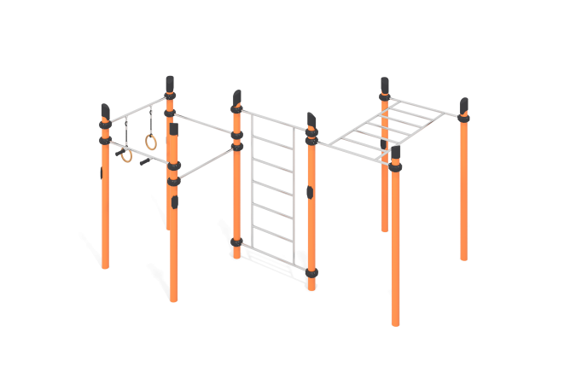

Size, mm: | 3050x3750x2600 | Weight, kg: | 309
Material characteristics
Materials: metal, stainless steel, powder paint, acrylic paint, varnish, plywood.
The complex consists of 8 support pillars made of a metal round pipe with a diameter of 108 mm and a wall thickness of 3.5 mm. The upper part of the pillars is closed with a plastic plug with a truncated cap.
The crossbars and gymnastic elements are connected to dismountable plastic clamps designed to connect two perpendicularly located pipes Ø108 mm and 33.5 mm (DN25). The clamp consists of 2 elements that are fixed together with bolts and nuts. The elements are made of glass-filled polyamide (PA6-GF30). The material is characterized by excellent performance characteristics: increased strength and durability, resistance to impact loads, the influence of high and low temperatures (from – 40 to +60 ° C) and UV radiation. There are rubber sealing inserts for reliable fixation - the clamp fits tightly to the pipe and does not slip during operation.
The crossbars, Swedish ladder, and press handle are made of a round pipe with a diameter of 32 mm with a wall thickness of 2 mm, made of AISI 304 stainless steel. The maximum load on the crossbar is 500 kg.
Gymnastic rings are made of high-strength, moisture-resistant birch plywood 27 mm thick, painted in 2 layers of tinted and clear varnish. Fastening to the crossbar is carried out using a flexible reinforced polypropylene rope with a diameter of 16 mm, consisting of six strands, each strand is reinforced with metal wires.
All existing metal parts are pre-cleaned, degreased and coated with polyester powder paint. The protruding parts of the threaded connections are closed with plastic plugs. All threaded fasteners are galvanized.
Complete set: support pillars – 8 pcs; crossbars – 4 pcs; clamps – 1 set; handlebar – 1 piece; Swedish ladder – 1 piece; gymnastic rings – 1 set.

