31.210 |  | Fitness equipment Ellipsoid
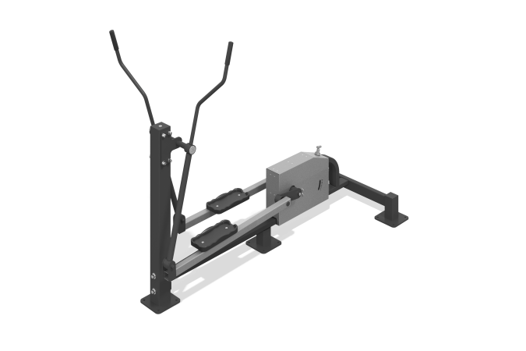

Size, mm: | 1000x2100x1705 | Weight, kg: | 71
Material characteristics
Materials: metal, LDPE.
The simulator is attached to a support post with a height of 1180 mm, made of a steel profile pipe 100 mm x 100 mm with a wall thickness of 4 mm, and a steel sheet 10 mm thick. The base of the outdoor cardio exercise machine is welded, made of steel profile pipe 50 x 50 mm with a wall thickness of 3 mm, steel profile pipe 80 x 80 mm with a wall thickness of 3 mm, steel profile pipe 80 x 40 mm with a wall thickness of 3 mm, steel profile pipe 120 x 60 mm with a wall thickness of 3 mm, steel rod with a diameter of 25 mm, steel pipe with a diameter of 20 mm with a wall thickness of 2.8 mm, a steel pipe with a diameter of 25 mm with a wall thickness of 2.8 mm, a steel pipe with a diameter of 34 mm with a wall thickness of 4 mm, a steel pipe with a diameter of 60 mm with a wall thickness of 6 mm, a steel pipe with a diameter of 108 mm with a wall thickness of 3.5 mm.
The connecting rod (2 pcs.) is welded, made of a steel pipe with a diameter of 60 mm with a wall thickness of 6 mm, a steel rod with a diameter of 60 mm and a steel sheet with a thickness of 10 mm. Movable arms (2 pcs.) are welded, made of steel profile pipe 50 x 50 mm with a wall thickness of 3 mm, steel rod with a diameter of 30 mm and steel sheets with a thickness of 4 mm and 6 mm.
The footrests on the levers are equipped with plastic linings made of high-density polyethylene (HDPE), with a textured surface that prevents the foot from slipping, with sides that increase the safety of use. Step height 265 mm.
Stick (2 pcs.) welded, made of steel pipe with a diameter of 42 mm with a wall thickness of 2.8 mm, a steel pipe with a diameter of 48 mm with a wall thickness of 6 mm, a steel pipe with a diameter of 60 mm with a wall thickness of 6 mm. The handles are made of bent steel pipe with a diameter of 25 mm and a wall thickness of 2.8 mm. The grip areas on the handles have pads made of EVA (ethylene vinyl acetate). The drum is covered on all sides with casings (2 pcs.). The casing is made of bent steel sheet 1.5 mm thick. On one of the casings there is a line of positions for adjusting the load of the inertia-free mechanism.
Changing the load of the inertia-free mechanism is achieved using the adjustment knob.
The inertia-free mechanism consists of a brake drum, shoe, spring, load lever, tensioner and slider. The drum is mounted on an axis with a holder - a welded structure, made of a steel rod with a diameter of 30 mm, the holder is made of a steel sheet 6 mm thick.
The mobility of the rotating elements is ensured by the use of closed radial bearings. To increase anti-corrosion properties, metal elements are coated with liquid zinc-rich primer. All metal elements are coated with anti-vandal decorative powder coating by pneumoelectrostatic spraying. The design of the simulator provides for its fixation to the base through holes with a diameter of 14 mm. The simulator fasteners are galvanized.
The exercise machine is designed for cardio training. Exercise performed: imitation of walking and running. The inertia-free load mechanism is achieved due to the friction force generated between the deceleration lever mechanism and the drum.

