44.001 |  | Educational Module Billiards
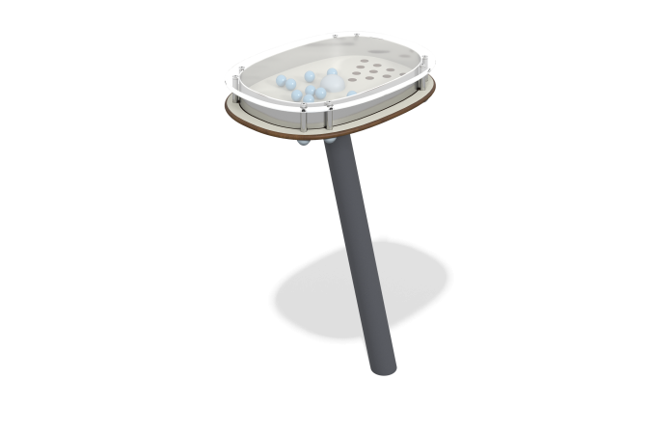

Size, mm: | 340x466x700 | Weight, kg: | 10.989
Material characteristics
Materials: Stainless steel, HPL plastic, polycarbonate, reinforced polypropylene rope d=16 mm, metal.
Design and color palette of equipment according to the sketch.
The educational element is a game panel with holes and balls that need to be rolled into the holes. The base of the module is made of HPL plastic, the guard is made of stainless steel, the cover is made of transparent polycarbonate. The module is mounted on a metal stand with a rotating element made of polypropylene rope, which ensures the movement of the gaming panel.

