21.039 |  | Rope Climbing Playground Serpinsky
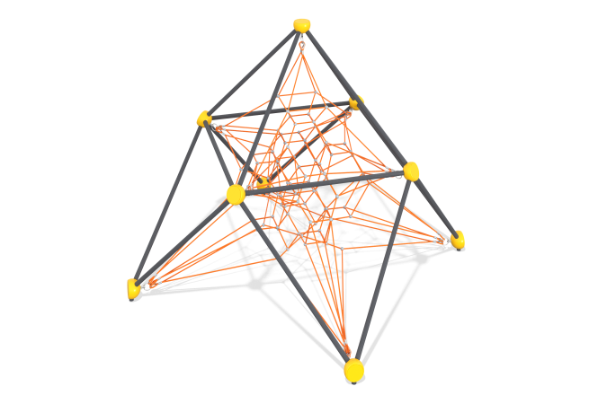

Size, mm: | 4610x4610x3498 | Weight, kg: | 263
Material characteristics
Materials: metal, rope
Complete set: supports - 4 pcs., rope net - 1 pc., fastener kit - 1 pc.
The metal frame consists of the following elements:
The ribs and supports of the structure are made of a pipe with a diameter of 57 mm and a wall thickness of 3 mm.
The spheres of the metal frame are made of cast aluminum alloy with a wall thickness of 8 mm, painted with powder polymer paints resistant to ultraviolet radiation and adverse weather conditions. They serve as connecting elements for the metal frame and the rope part, connected to each other using a bolted connection M12, made of stainless steel;
The ribs and spheres are connected to each other using a bolted connection made of stainless steel.
The rope part consists of the following elements:
The net is made of a reinforced six-strand rope with a diameter of 16 mm, consisting of polypropylene threads and steel wire. The rope provides increased resistance of the net to ultraviolet radiation. ;
Cross-shaped connectors of the rope part are made of cast polyamide, fixed with stainless self-tapping screws;
The ends of the rope part are threaded with a loop through a metal thimble and fixed with a compression sleeve made of aluminum alloy. Strap tensioners made of high-quality black steel, protected from corrosion by galvanization, are threaded through the thimbles. The thimbles are equipped with polyethylene inserts that perform a protective and decorative function;
T-shaped connections are realized with the help of compression sleeves made of aluminum alloys.
The equipment uses stainless steel fasteners. Protruding parts of threaded connections and open parts of pipes are closed with plastic plugs
Coating of elements: metal - powder zinc primer, powder paint.

