21.057 |  | Rope Climbing Playground Kepler
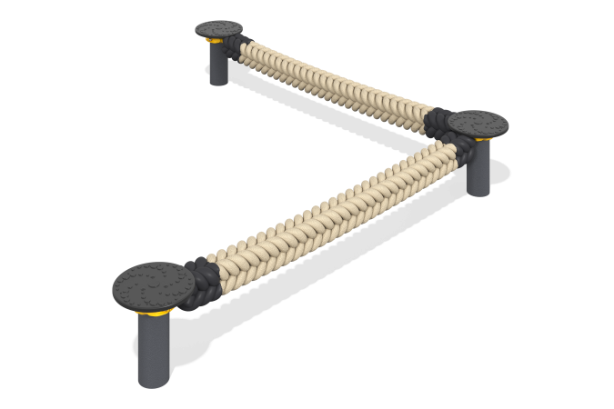

Size, mm: | 3390x3390x620 | Weight, kg: | 120
Material characteristics
Main materials: metal, polypropylene rope, stainless steel fasteners, rubber.
Contents: embedded parts - 1 set, rope structure - 2 pcs., support posts - 3 pcs., clamp with fastening kit - 3 pcs.
Design and color palette of equipment according to the sketch.
The design is a suspended bridge and is intended for installation on open playgrounds. The bridge consists of a square Viking polypropylene rope with a cross-section of 140x140 mm, which is attached at its ends to two supporting metal posts. The metal racks are covered with rubber corrugated discs.
The complex uses stainless steel fasteners.
Element coverage:
- metal - powder zinc primer, powder paint.

