21.068 |  | Rope Climbing Playground Copernicus
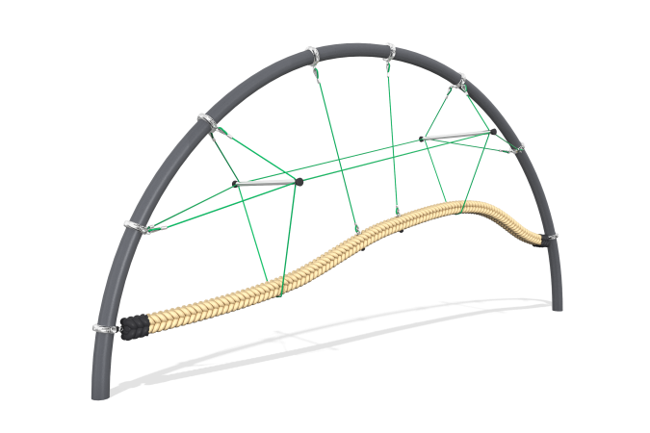

Size, mm: | 1100x6000x3000 | Weight, kg: | 0
Material characteristics
Materials: metal, rope.
Package includes: supports - 2 pcs., rope net - 1 pc., fastener kit - 1 pc.
The "Copernicus" rope crossing is a semicircular metal arch, inside which a rope suspension bridge is fixed, and is intended for installation on open playgrounds. The bridge is made of a reinforced polypropylene rope of a round cross-section with a diameter of 150 mm, which is attached at its ends to a metal arch made of a pipe with a diameter of 133 m, and sections of a polypropylene six-strand reinforced rope with a diameter of 16 mm, which act as a railing and support the suspension bridge in the middle. The rope part is assembled into a single spatial structure using plastic and aluminum connectors.
Protruding parts of threaded connections and open parts of pipes are closed with plastic plugs
Coating of elements: metal - powder zinc primer, powder paint.

