21.066 |  | Rope Climbing Playground Descartes
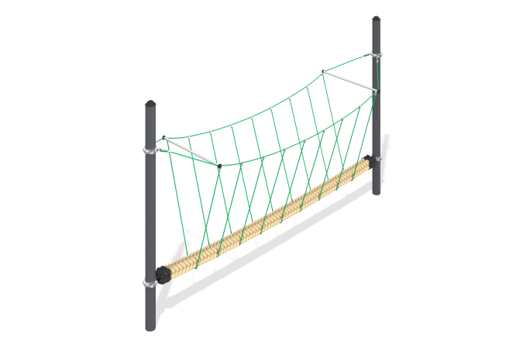

Size, mm: | 1150x4500x2303 | Weight, kg: | 270
Material characteristics
Materials: metal, rope,.
Package includes: support post - 2 pcs., rope crossing - 1 pc., fastener kit - 1 pc.
The structure is a suspended bridge and is intended for installation on open playgrounds. The bridge consists of a reinforced polypropylene rope of a round cross-section with a diameter of 150 mm, which is attached at its ends to two supporting metal posts with a diameter of 133 m. The railings of the bridge are stretched between the supporting posts parallel to the rope with a diameter of 1500 mm and connected to it by vertical slings made of sections of polypropylene six-strand reinforced rope with a diameter of 16 mm, assembled into a single spatial structure using plastic and aluminum connectors. The height of the supporting posts is 2250 mm. The length and width of the structure are 4500 and 1150 mm, respectively.
The protruding parts of the threaded connections and the open parts of the pipes are covered with plastic plugs
Coating of the elements: metal - powder zinc primer, powder paint.

