21.064 |  | Rope Climbing Playground Newton
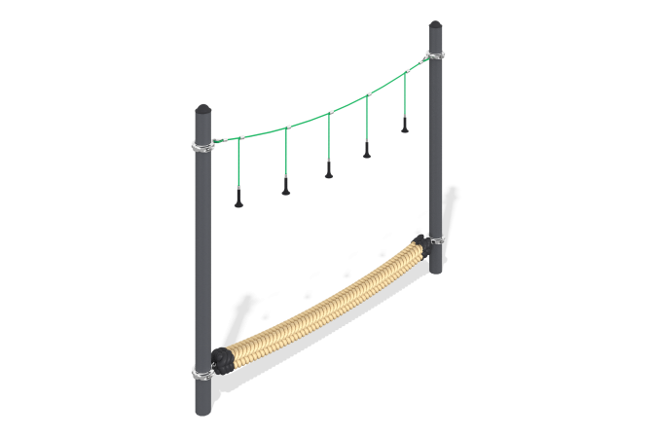

Size, mm: | 208x3188x2051 | Weight, kg: | 162
Material characteristics
Materials: metal, rope,.
Complete set: supports - 2 pcs., rope - 1 pc., fastener kit - 1 pc.
The "Newton" rope crossing consists of a metal frame and a rope part.
The metal frame consists of the following elements:
Two support posts are made of a metal pipe with a diameter of 133 mm and a wall thickness of 4.5 mm, having a support plate measuring 250 mm x 250 mm.
The rope part consists of the following elements:
The slings are made of a reinforced six-strand rope with a diameter of 16 mm, consisting of polypropylene threads and steel wire. The rope provides increased resistance of the net to ultraviolet radiation. ;
The ends of the sling are threaded in a loop through a metal thimble and fixed with a crimping sleeve made of aluminum alloy.
T-shaped connections of suspension ropes are implemented using compression sleeves made of aluminum alloys. The ends of the suspension ropes together with the threaded stud are fixed with compression sleeves made of aluminum alloys.
Plastic cone-shaped handle for a threaded stud. Handle length - 122 mm. The product is used as a hand grip. The grip is ribbed, which prevents slipping. In this version, the handle is strung on a threaded stud and fixed with a nut made of stainless steel.
The braided rope has a round cross-section with a diameter of 150 mm. The rope is made of polypropylene fiber, has a steel core with a diameter of 12 mm. The ends of the core are threaded with a loop through a metal thimble and fixed with a compression sleeve made of aluminum alloy. The ends are wrapped with a soft rope, protecting the free ends of the braided rope from fraying, and heat shrinkage resistant to ultraviolet radiation is installed on top. The rope is characterized by increased strength, the breaking load is 300 tons, has excellent resistance to abrasion, and good resistance to ultraviolet radiation.
The clamps are made of two halves connected to each other using bolted connections, made of stainless steel. Designed for mounting a pipe with a diameter of 133 mm.
The protruding parts of the threaded connections and the open parts of the pipes are closed with plastic plugs
Coating of elements: metal - powder zinc primer, powder paint.

