17.009 |  | Cradle Seat
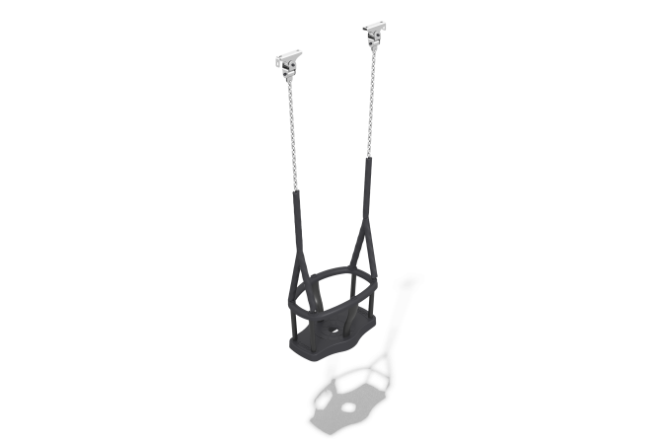

Size, mm: | 287x480x1482 | Weight, kg: | 4.62
Material characteristics
Materials: metal, rubber.
Package includes: rubber suspension – 1 pc., fastener kit – 1 pc.
Seat, closed, made of thermoplastic, and has protective vertical stops and a rim with metal reinforcement for strength. Inside the seat structure, there is a metal plate for increased strength. Chain: short-link galvanized, chain link cross-section diameter 6 mm. The chain is protected by a heat-shrinkable sheath.
Protruding parts of threaded connections and open parts of pipes are covered with plastic plugs
Coating of elements: metal - powder zinc primer, powder paint.

