31.208 |  | Fitness equipment Rowing
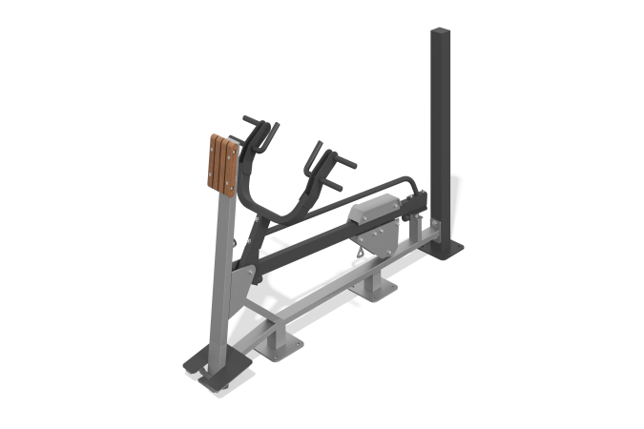

Size, mm: | 950x2090x1380 | Weight, kg: | 160
Material characteristics
Materials: metal, planed pine board, plastic.
The simulator is designed to train the back muscles. The simulator is attached to a support column made of a steel profile pipe 100 mm x 100 mm with a wall thickness of 4 mm, and a steel sheet 10 mm thick. The main frame of the simulator is welded, the frame support is made of steel profile pipe 80 x 80 mm with a wall thickness of 3 mm, steel sheet 10 mm thick. The main structure of the simulator frame is made of a mandrel-curved pipe, which eliminates deformation of the surface of the pipe in the form of waves and creases in places of bending, a steel profile pipe 80 x 40 mm with a wall thickness of 3 mm, and a supporting steel profile pipe 100 x 50 mm with a wall thickness of 3 mm, tied with steel plates 8 and 10 mm thick. On the main frame there is a foot rest, located 70 mm from the ground level, for different positions of the student, made of a 50 x 25 mm profile pipe with a wall thickness of 1.5 mm and a 4 mm thick corrugated steel sheet, which ensures good grip of the legs with the platform.
The exercise, row to the chest, is performed while standing, by transferring force from the handles for rowing, which have a common welded structure with a movable lever on which the load moves. The movable lever with handles is welded, made of straight and curved mandrel method, which eliminates deformation of the surface of the pipe in the form of waves and creases in places of bending, a steel profile pipe 80 x 40 mm with a wall thickness of 3 mm and a steel sheet 6 mm thick. The lever is equipped with two pairs of grip handles. The handles are made of steel rod with a diameter of 25 mm. The grip areas on the handles have pads made of EVA material.
The movable lever on which the load moves is welded, made of steel profile pipe 80 x 40 mm with a wall thickness of 3 mm. It is attached to the support post and the system of auxiliary levers using shafts made of steel rod with a diameter of 48 mm and a steel sheet with a thickness of 10 mm.
For ease of use, there is a metal position indicator with numbers on the side of the lever.
At the end of the lever with the load there is a limiter that serves as a limiter for the movement of the load; it is a welded structure made of a steel pipe with a diameter of 33 mm with a wall thickness of 2.8 mm, with connecting flanges made of steel sheet with a thickness of 10 mm, and a stop made of a steel pipe with a diameter of 48 mm and a wall thickness of 2.8 mm.
The simulator is equipped with a load regulation mechanism.
The weight is made in the form of a set of welded steel sheets 10mm thick and a steel strip 10x100mm, with a system to ensure smooth movement. The movable load can be fixed in ten positions to increase resistance (load). Mechanism weight 50 kg. The movable load has a conveniently shaped grip and a simple mechanism for fixing it in certain places. To move the load, simply press the lever, place the weight at the desired point, and release the lever. Additional safety fixation of the weight with a stainless screw is provided.
To increase anti-corrosion properties, metal elements are coated with liquid zinc-rich primer.
All metal elements are coated with anti-vandal decorative powder coating by pneumoelectrostatic spraying.
The chest support element is made of planed softwood boards, dried and treated with protective materials to ensure strength and wear resistance in the external environment.
The simulator fasteners are galvanized.

