31.207 |  | Fitness equipment Leg spread
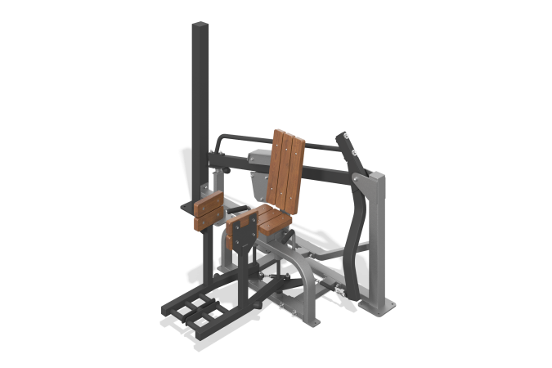

Size, mm: | 1390x2060x1410 | Weight, kg: | 160
Material characteristics
Materials: metal, planed pine board.
The simulator is designed to perform exercises aimed at training the muscles of the outer thigh (gluteus maximus, gluteus medius, piriformis, tensor fasciae lata). Exercise performed: Leg abduction to the sides in a sitting position.
Starting position: Sitting, legs together.
The simulator is attached to a support column made of a steel profile pipe 100 mm x 100 mm with a wall thickness of 4 mm, and a steel sheet 10 mm thick.
Consists of: base, main frame, lever with weight, 2 movable levers.
The main frame of the simulator is welded, made of a mandrel-bent pipe, which eliminates deformation of the surface of the pipe in the form of waves and creases in bending areas, a steel profile pipe 80 x 40 mm with a wall thickness of 3 mm, a steel profile pipe 80 x 80 mm with a wall thickness of 3 mm, steel sheets with a thickness of 3 mm, 10 mm.
The base is made of a steel profile pipe 80 x 40 mm with a wall thickness of 3 mm, a steel profile pipe 80 x 80 mm with a wall thickness of 3 mm, a steel pipe with a diameter of 60 mm with a wall thickness of 6 mm, a steel rod with a diameter of 25 mm, steel sheets with a thickness of 6 mm, 8 mm, 10 mm. The lever with the load on which the load moves is welded, made of a steel profile pipe 80 x 40 mm with a wall thickness of 3 mm, a steel pipe with a diameter of 48 mm with a wall thickness of 2.8 mm, steel sheets with a thickness of 6 mm, 8 mm, 4 mm, a steel pipe with a diameter of 60 mm and a wall thickness of 6 mm.
For ease of use, there is a metal position indicator with numbers on the side of the lever. The simulator is equipped with a load regulation mechanism.
The weight is made in the form of a set of welded steel sheets 10mm thick and a steel strip 10x100mm, with a system to ensure smooth movement. The movable load can be fixed in ten positions to increase resistance (load). Mechanism weight 50 kg. The movable load has a conveniently shaped grip and a simple mechanism for fixing it in certain places. To move the load, simply press the lever, place the weight at the desired point, and release the lever. Additional safety fixation of the weight with a stainless screw is provided. The simulator is equipped with two movable weights.
To increase anti-corrosion properties, metal elements are coated with liquid zinc-rich primer. All metal elements are coated with anti-vandal decorative powder coating by pneumoelectrostatic spraying.
The seat, backrest and foot rests are rounded, made of planed softwood boards, dried and treated with protective materials to ensure strength and wear resistance in the external environment.
The simulator fasteners are galvanized.
The simulator has holes with a diameter of 14 mm for attaching it to the platform.

