31.205 |  | Fitness equipment Seated chest press
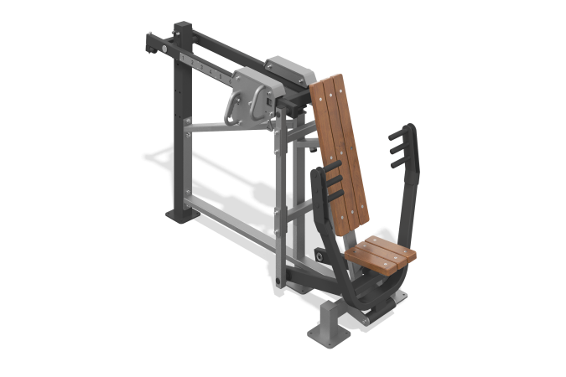

Size, mm: | 920x2290x1420 | Weight, kg: | 215
Material characteristics
Materials: metal, planed pine board, plastic.
The machine is designed to train the chest muscles. The simulator is attached to a support column made of a steel profile pipe 100 x 100 mm with a wall thickness of 4 mm, and a steel sheet 10 mm thick. The base of the simulator is welded, made of steel profile pipe 80 x 80 mm with a wall thickness of 3 mm, steel profile pipe 80 x 40 mm with a wall thickness of 3 mm, steel pipe with a diameter of 48 mm with a wall thickness of 2.8 mm, steel sheets with thicknesses: 3 mm, 4 mm, 6 mm, 8 mm, 10 mm.
The rod with handles for the bench press is welded, made of steel profile pipe 100 x 50 mm with a wall thickness of 3 mm, straight and bent using the mandrel method, which eliminates deformation of the pipe surface in the form of waves and creases in places of bending, steel profile pipe 80 x 40 mm with a wall thickness of 3 mm, steel pipe with a diameter of 60 mm with a wall thickness of 6 mm and steel sheets with a thickness of 4 mm, 6 mm, 10 mm. The rod is equipped with three pairs of grip handles. The handles are made of steel rod with a diameter of 25 mm. The grip areas on the handles have pads made of polyurethane.
The movable lever on which the load moves is welded, made of a steel profile pipe 80 x 40 mm with a wall thickness of 3 mm, a steel pipe with a diameter of 48 mm with a wall thickness of 2.8 mm, a steel pipe with a diameter of 60 mm with a wall thickness of 6 mm, steel sheets with a thickness of 4 mm, 10 mm. Attached to the support column and the system of auxiliary levers using shafts made of steel rod with a diameter of 48 mm and a steel sheet 10 mm thick.
For ease of use, there is a metal position indicator with numbers on the side of the lever.
The auxiliary lever serves to communicate the lever with the rod, a welded structure, made of a steel profile pipe 50 x 50 mm with a wall thickness of 3 mm, a steel rod with a diameter of 35 mm, steel sheets with a thickness of 3 mm, 4 mm.
The auxiliary levers are connected to each other by welded ties (2 pcs.), made from a steel profile pipe 50 x 50 mm with a wall thickness of 3 mm.
At the end of the lever with the load there is a limiter that serves as a limiter for the movement of the load, made of a steel profile pipe 50 x 50 mm with a wall thickness of 3 mm GOST 8639-82, and a stop made of a steel pipe with a diameter of 48 mm with a wall thickness of 2.8 mm and a steel sheet 4 mm thick.
The simulator is equipped with a load regulation mechanism.
The weight is made in the form of a set of welded steel sheets 10 mm thick and a steel strip 10 x 100 mm, with a system to ensure smooth movement. The movable load can be fixed in ten positions to increase resistance (load). Mechanism weight 50 kg. The movable load has a conveniently shaped grip and a simple mechanism for fixing it in certain places. To move the load, simply press the lever, place the weight at the desired point, and release the lever. Additional safety fixation of the weight with a stainless screw is provided. The simulator is equipped with two movable weights.
To increase anti-corrosion properties, metal elements are coated with liquid zinc-rich primer.
All metal elements are coated with anti-vandal decorative powder coating by pneumoelectrostatic spraying. The seat and back are made of planed softwood boards, dried in accordance with the treatment with protective materials to ensure strength and wear resistance in the external environment. Seat height 470 mm from the ground. The angle of the backrest relative to the seat is 100 degrees.
The simulator fasteners are galvanized.

