31.202 |  | Fitness equipment Angled leg press
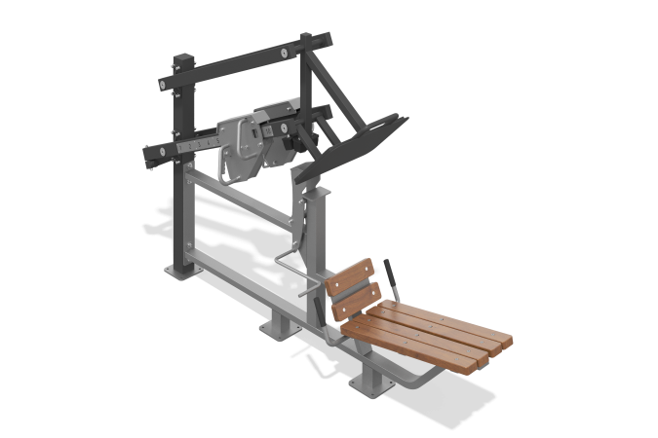

Size, mm: | 710x2750x1740 | Weight, kg: | 267
Material characteristics
Materials: metal, planed pine board, plastic.
The machine is designed to perform the leg press exercise in a lying position at an angle of 45 degrees. The simulator is attached to a support column made of a steel profile pipe 100 mm x 100 mm with a wall thickness of 4 mm, and a steel sheet 10 mm thick. The main frame of the simulator is welded, the frame support is made of steel profile pipe 80 x 80 mm with a wall thickness of 3 mm, steel sheet 10 mm thick. The main structure of the simulator frame is made of a steel profile pipe 80 x 40 mm with a wall thickness of 3 mm, bent by the mandrel method, which eliminates deformation of the pipe surface in the form of waves and creases in places of bending, tied with steel plates 8 and 10 mm thick.
The exercise is performed half-sitting, by transferring the force with the legs to a movable platform, and then to a movable lever to move the weight with a movable load. The movement is plane-parallel, the angle of inclination of the moving platform relative to the bench is 33 degrees. Parallel movement is ensured by two auxiliary levers made of steel profile pipe 80 x 40 mm with a wall thickness of 3 mm.
The simulator has a dismountable-welded safety mechanism, which increases the safety of using the simulator and is an easy start when performing the exercise. The safety mechanism is made of a steel sheet 8 mm thick, a steel rod with a diameter of 20 mm and a steel pipe with a diameter of 25 mm with a wall thickness of 7 mm. Assembled using galvanized fasteners.
The moving platform consists of a welded frame made of steel profile pipe 50 x 50 mm with a wall thickness of 3 mm and corrugated steel sheet 4 mm thick, ensuring good adhesion of the legs to the platform. The platform is also equipped with an auxiliary handle made of a bent rod with a diameter of 25 mm, for taking a more comfortable starting position on the bench at the beginning of the exercise.
The movable lever for moving weights with a movable load is made of steel profile pipe 80 x 40 mm with a wall thickness of 3 mm. It is attached to the support column and the system of auxiliary levers using shafts made of steel rod with a diameter of 48 mm and a steel sheet with a thickness of 10 mm.
For ease of use, there is a metal position indicator with numbers on the side of the lever. At the end of the lever with the load there is a limiter that serves as a limiter for the movement of the load, made of a steel profile pipe 50 x 50 mm with a wall thickness of 3 mm, and a stop made of a steel pipe with a diameter of 48 mm and a wall thickness of 2.8 mm.
The simulator is equipped with a load regulation mechanism. The weight is made in the form of a set of welded steel sheets 10mm thick and a steel strip 10x100mm, with a system to ensure smooth movement. The movable load can be fixed in ten positions to increase resistance (load). Mechanism weight 50 kg. The movable load has a conveniently shaped grip and a simple mechanism for fixing it in certain places.
All ends of the pipes are plugged. The simulator is equipped with two movable weights.
The seat and back are made of planed softwood boards, dried and treated with protective materials to ensure strength and wear resistance in the external environment.
To increase anti-corrosion properties, metal elements are coated with liquid zinc-rich primer.
All metal elements are coated with anti-vandal decorative powder coating by pneumoelectrostatic spraying. The thickness of the coating layer is 80-150 microns.
The grip areas on the handles have pads made of EVA (ethylene vinyl acetate).
The simulator fasteners are galvanized.

